
CCTV & SURVEILLANCE SYSTEM

NexPro 4MP High-Brightness Dual-Light Dome (12-LED, Two-Way Audio)
  - Exact model: NexPro-DM206D3-4MP-DIC-DJ
PRODUCT IMAGES
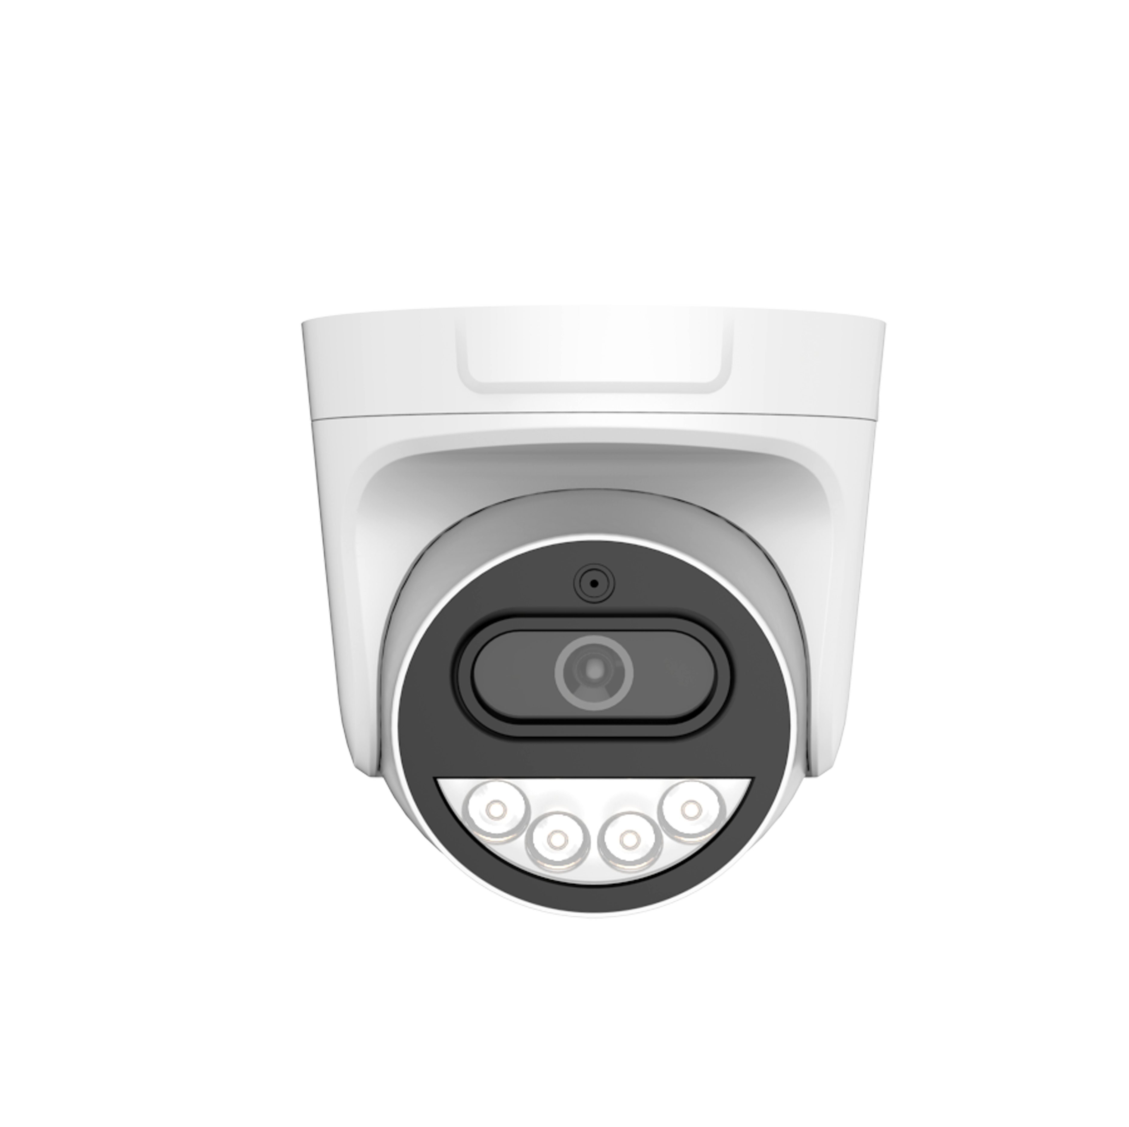
NexPro-DM206D3-4MP-DIC-DJ · Primary

PRODUCT OVERVIEW
4MP full-color, dual-IC, 12 high-power LEDs, two-way audio, 4000V surge protection
Product line | CCTV & Surveillance System
Series / family | 206
Exact model | NexPro-DM206D3-4MP-DIC-DJ
Applications | Indoor Premium, Lobby, Commercial
MODEL IDENTIFICATION
Exact model | Product / variant | Resolution | Lens | Illuminator
NexPro-DM206D3-4MP-DIC-DJ | NexPro 4MP High-Brightness Dual-Light Dome (12-LED, Two-Way Audio) | 4MP (5MP sensor) | F1.4 5MP fixed | 12-LED high-power (1W)
TECHNICAL SPECIFICATIONS
Parameter | Specification
Resolution | 4MP (5MP sensor); 4MP (2560×1440) @ real-time
Lens | F1.4 5MP fixed lens
Illuminator | 12-LED high-power  (1W); 12-LED high-power dual light (6×20mil IR + 6×1W warm white)
Camera Type | 4MP High-Brightness Full-Color Dual-Light Network Dome Camera with Two-Way Audio  (206 Series)
Solution | Tianview TB38Y51 (5MP sensor, output 4MP)
Image Sensor | 1/2.7″ 5MP CMOS, low illumination
Lamp Board | Dual IC circuit design
Audio | Built-in microphone and speaker (two-way audio)
Protection | Metal front cover, 4000V lightning surge protection
Light Control | 3 switchable modes
Quotation Type | Bulk project quotation
OEM/ODM | Available for selected orders
Documents | Datasheet and installation reference
Category | CCTV System
APPLICATIONS & RFQ CONFIRMATION
Typical applications | Confirm in the project RFQ
Indoor Premium  Lobby  Commercial | Confirm the exact model and required configuration.  Confirm quantity, destination, packing, branding, and documentation requirements.
Project supply: MOQ — Confirm by project quantity · Lead time — Confirm by project list · FOB port — China main ports · OEM/ODM — Available; confirm project scope
PROJECT CONFIGURATION CHECKLIST
Exact model | NexPro-DM206D3-4MP-DIC-DJ
Application and site conditions | Confirm installation environment and operating requirements.
Quantity and model mix | Confirm forecast quantity, phase plan and required variants.
Interfaces and accessories | Confirm compatible interfaces, accessories and system integration scope.
Finish, branding and packing | Confirm only when project customization is required.
Documentation and destination | Confirm drawings, datasheets, packing documents and destination country or port.

