
CCTV & SURVEILLANCE SYSTEM

NexPro 4MP Bullet (5MP Sensor, 9017, Triode, 24-LED, Audio)
  - Exact model: NexPro-BL9017Y51-4MP-TRI
PRODUCT IMAGES
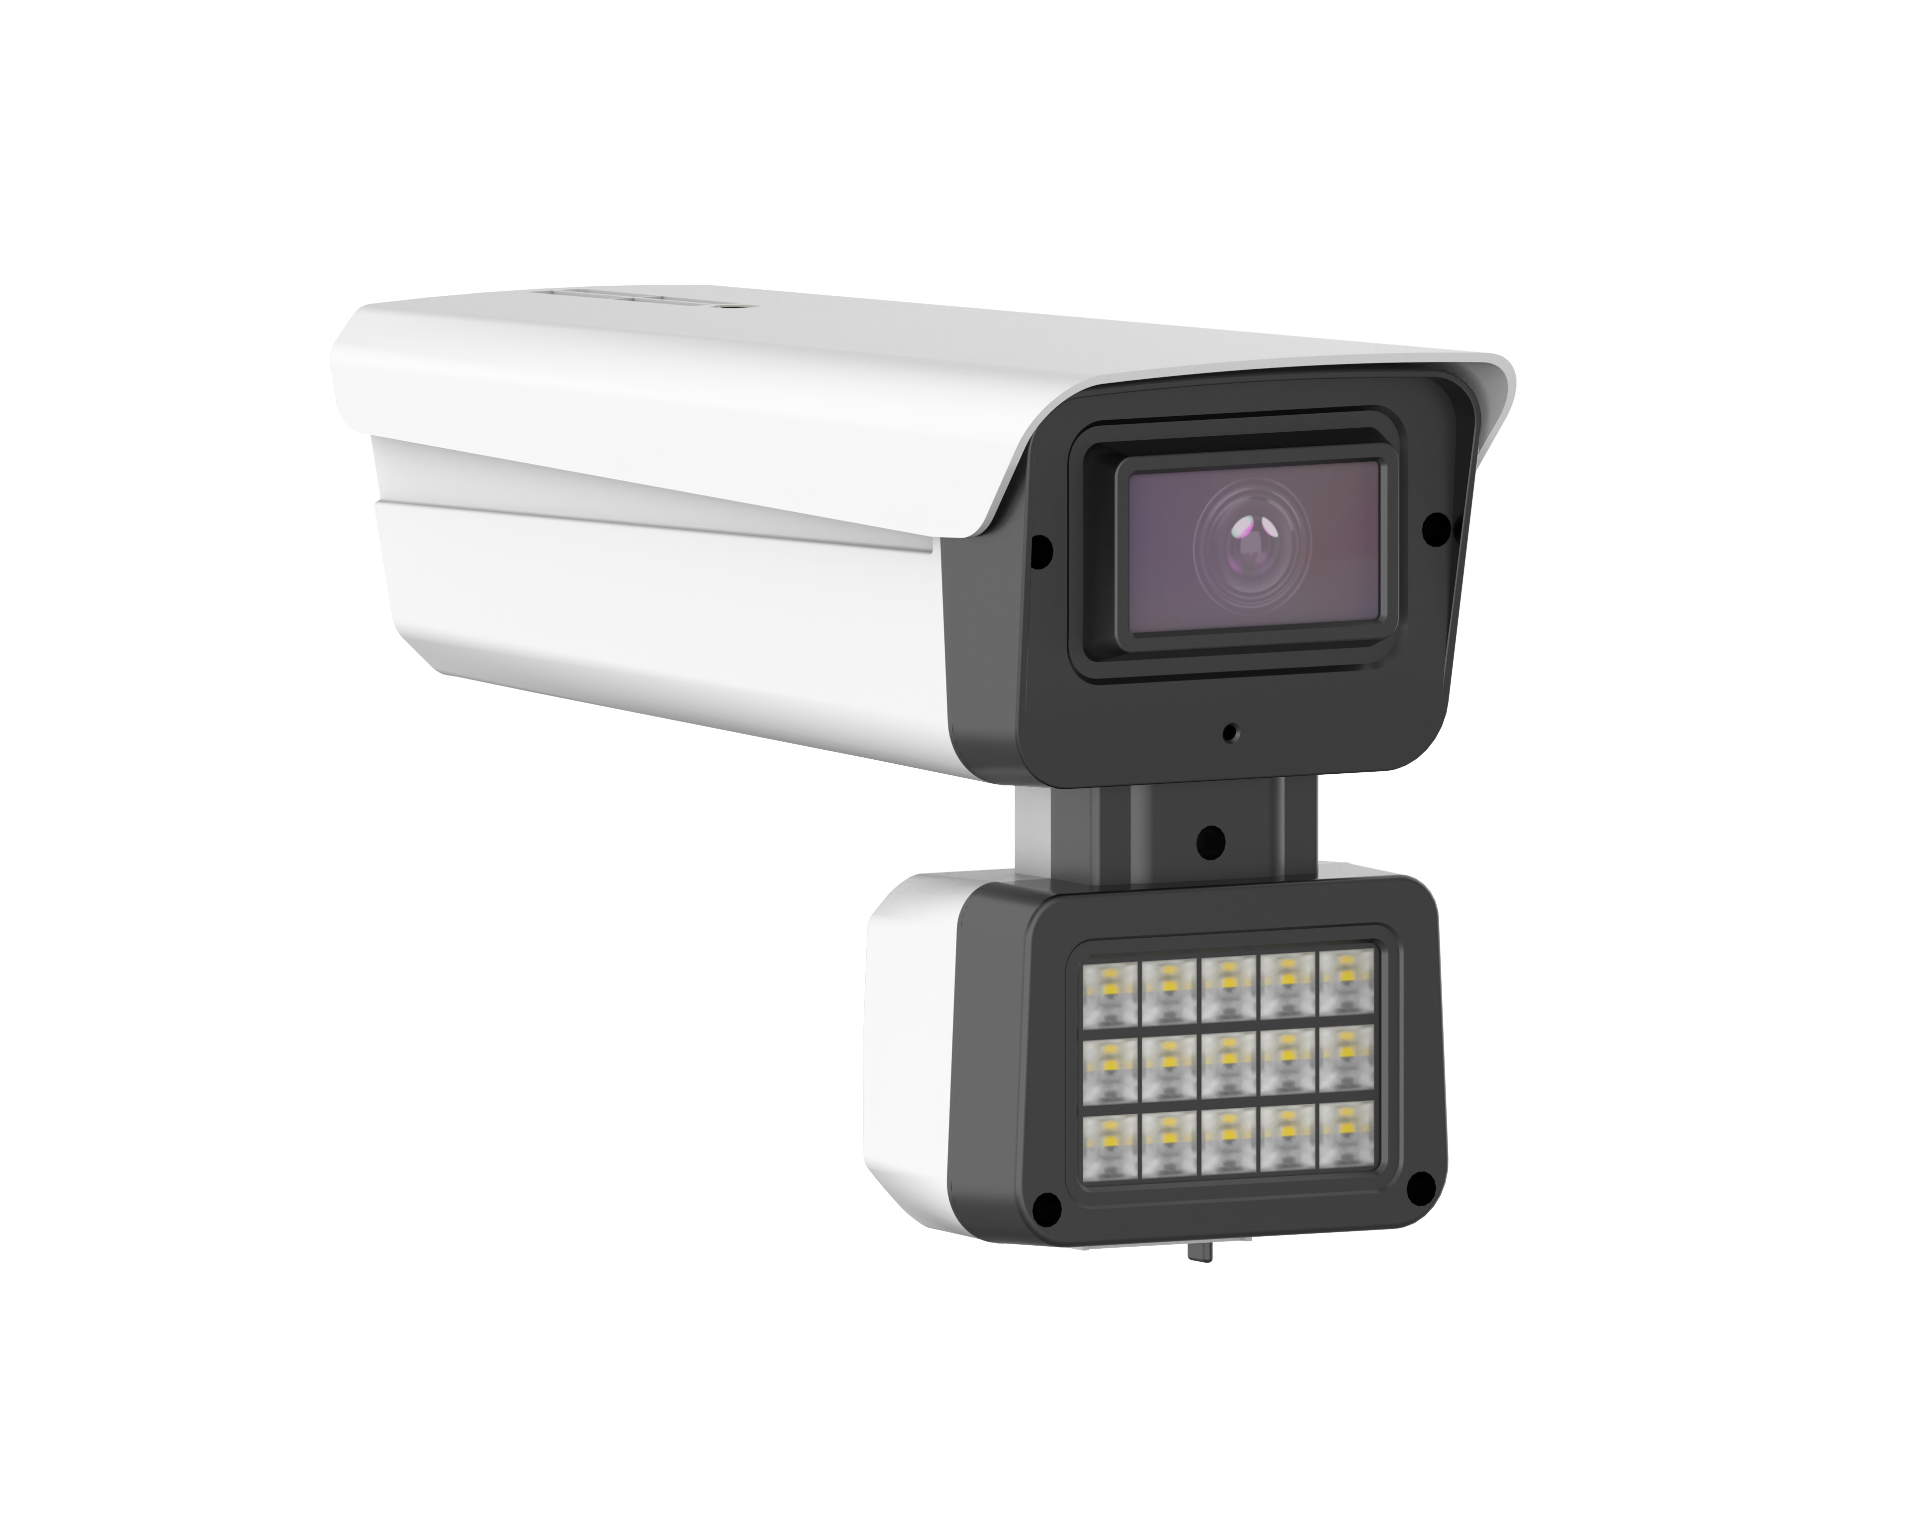
NexPro-BL9017Y51-4MP-TRI · Primary

PRODUCT OVERVIEW
5MP sensor, 4MP output, triode lamp, 24 LEDs (1W), built-in mic, 4000V surge protection
Product line | CCTV & Surveillance System
Series / family | 9017
Exact model | NexPro-BL9017Y51-4MP-TRI
Applications | Perimeter, Loading Dock, Industrial
MODEL IDENTIFICATION
Exact model | Product / variant | Resolution | Lens | Illuminator
NexPro-BL9017Y51-4MP-TRI | NexPro 4MP Bullet (5MP Sensor, 9017, Triode, 24-LED, Audio) | 4MP (5MP sensor) | F1.4 5MP fixed | 24-LED triode (1W)
TECHNICAL SPECIFICATIONS
Parameter | Specification
Resolution | 4MP  (5MP sensor); 4MP (2560×1440) @ real-time (5MP sensor improves low-light capture)
Lens | F1.4 5MP fixed lens
Illuminator | 24-LED triode  (1W); 24-LED dual light (12×20mil IR + 12×1W warm white)
Camera Type | 4MP Full-Color Network Bullet Camera  (5MP Sensor, 9017 Housing)
Solution | Tianview TB38Y51
Image Sensor | 1/2.7″ 5MP CMOS, low illumination
Lamp Board | Triode circuit design
Audio | Built-in microphone
Protection | Metal front cover, 4000V lightning surge protection
Light Control | 3 switchable modes
Quotation Type | Bulk project quotation
OEM/ODM | Available for selected orders
Documents | Datasheet and installation reference
Category | CCTV System
APPLICATIONS & RFQ CONFIRMATION
Typical applications | Confirm in the project RFQ
Perimeter  Loading Dock  Industrial | Confirm the exact model and required configuration.  Confirm quantity, destination, packing, branding, and documentation requirements.
Project supply: MOQ — Confirm by project quantity · Lead time — Confirm by project list · FOB port — China main ports · OEM/ODM — Available; confirm project scope
PROJECT CONFIGURATION CHECKLIST
Exact model | NexPro-BL9017Y51-4MP-TRI
Application and site conditions | Confirm installation environment and operating requirements.
Quantity and model mix | Confirm forecast quantity, phase plan and required variants.
Interfaces and accessories | Confirm compatible interfaces, accessories and system integration scope.
Finish, branding and packing | Confirm only when project customization is required.
Documentation and destination | Confirm drawings, datasheets, packing documents and destination country or port.

