
CCTV & SURVEILLANCE SYSTEM

NexPro 8MP 4K AI Bullet (Sony 415, F1.0, Two-Way Audio)
  - Exact model: NexPro-BL9017K20-8MP
PRODUCT IMAGES
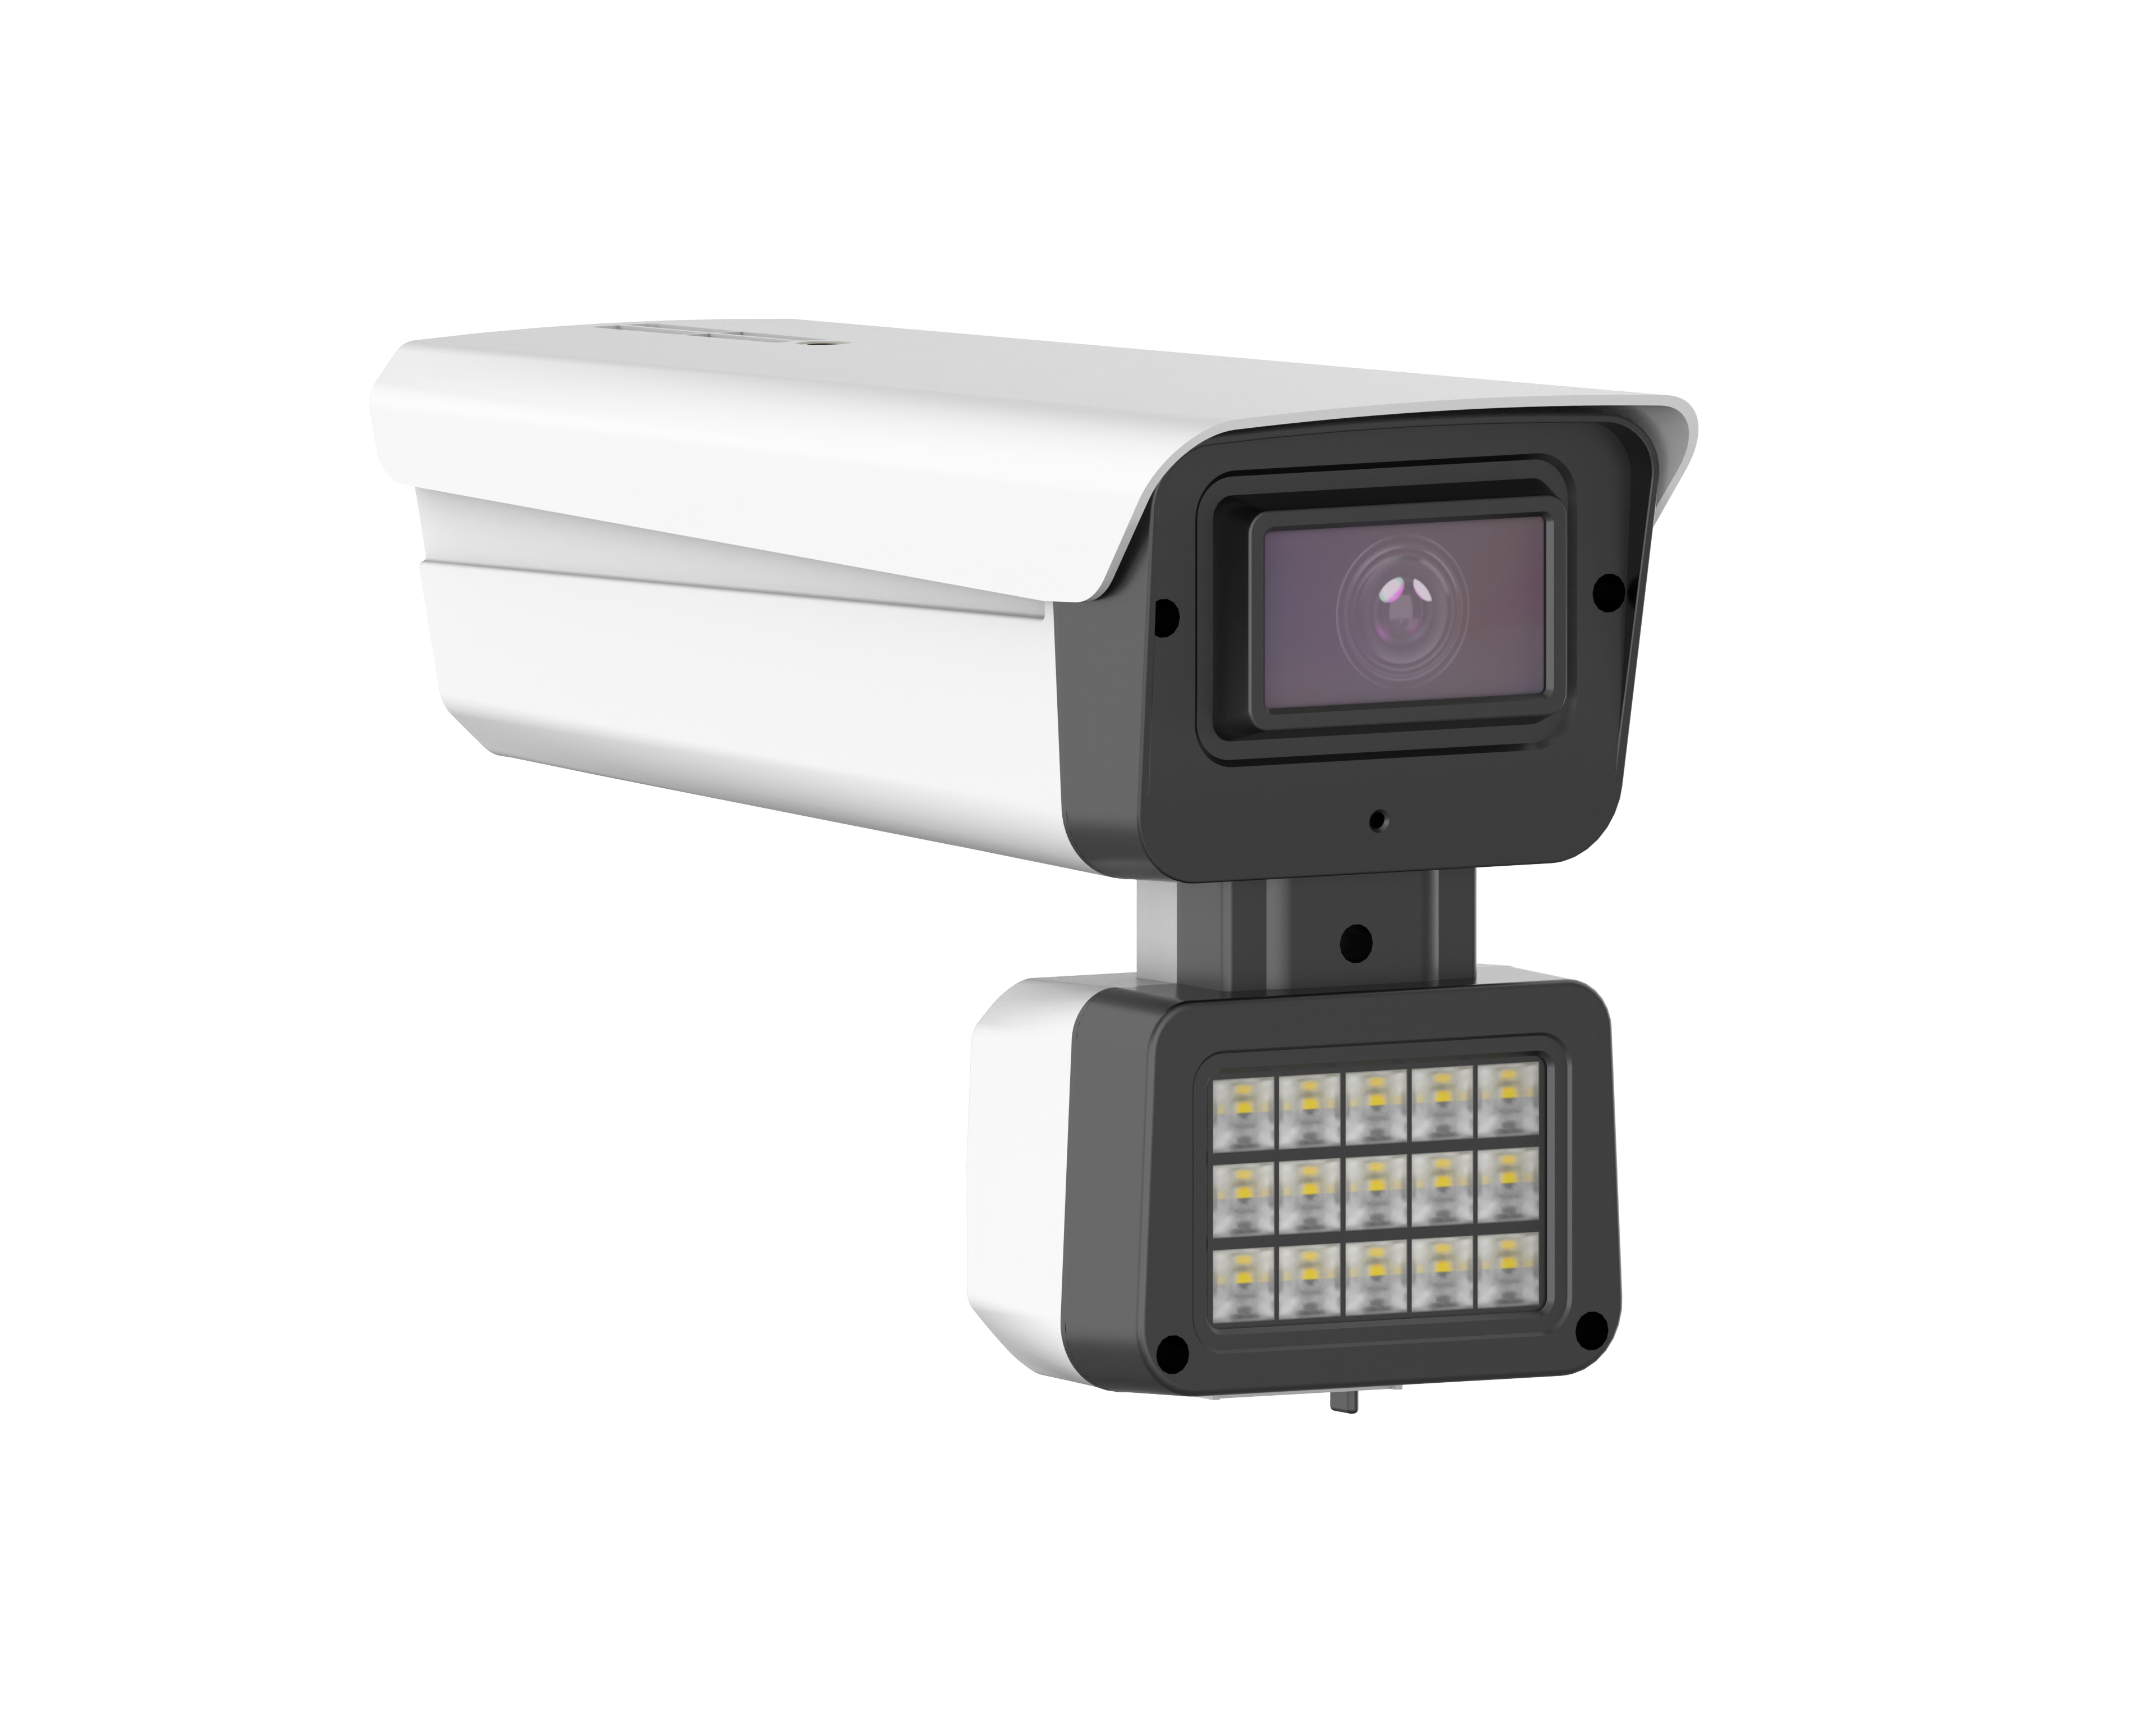
NexPro-BL9017K20-8MP · Primary

PRODUCT OVERVIEW
8MP 4K, Sony STARVIS 415 sensor, F1.0 blacklight lens, ultra-low light, built-in speaker, two-way audio
Product line | CCTV & Surveillance System
Series / family | Standalone model
Exact model | NexPro-BL9017K20-8MP
Applications | Premium Perimeter, Critical Infrastructure, VIP Entrance
MODEL IDENTIFICATION
Exact model | Product / variant | Resolution | Sensor | Lens
NexPro-BL9017K20-8MP | NexPro 8MP 4K AI Bullet (Sony 415, F1.0, Two-Way Audio) | 8MP (4K) | Sony STARVIS 415 | F1.0 blacklight
TECHNICAL SPECIFICATIONS
Parameter | Specification
Resolution | 8MP (4K)
Sensor | Sony STARVIS 415
Lens | F1.0 blacklight lens
Camera Type | 8MP 4K AI Network Bullet Camera with F1.0 Blacklight Lens
Image Sensor | Sony STARVIS 415 8MP (4K), ultra-low illumination
AI Features | Vehicle and human detection
Audio | Built-in speaker, two-way intercom
Video | H.265, 4K resolution
Quotation Type | Bulk project quotation
OEM/ODM | Available for selected orders
Documents | Datasheet and installation reference
Category | CCTV System
APPLICATIONS & RFQ CONFIRMATION
Typical applications | Confirm in the project RFQ
Premium Perimeter  Critical Infrastructure  VIP Entrance | Confirm the exact model and required configuration.  Confirm quantity, destination, packing, branding, and documentation requirements.
Project supply: MOQ — Confirm by project quantity · Lead time — Confirm by project list · FOB port — China main ports · OEM/ODM — Available; confirm project scope
PROJECT CONFIGURATION CHECKLIST
Exact model | NexPro-BL9017K20-8MP
Application and site conditions | Confirm installation environment and operating requirements.
Quantity and model mix | Confirm forecast quantity, phase plan and required variants.
Interfaces and accessories | Confirm compatible interfaces, accessories and system integration scope.
Finish, branding and packing | Confirm only when project customization is required.
Documentation and destination | Confirm drawings, datasheets, packing documents and destination country or port.

