
CCTV & SURVEILLANCE SYSTEM

NexPro 5MP Compact Dual-Light Bullet (8-LED, Audio)
  - Exact model: NexPro-BL1050M55-5MP-DIC
PRODUCT IMAGES
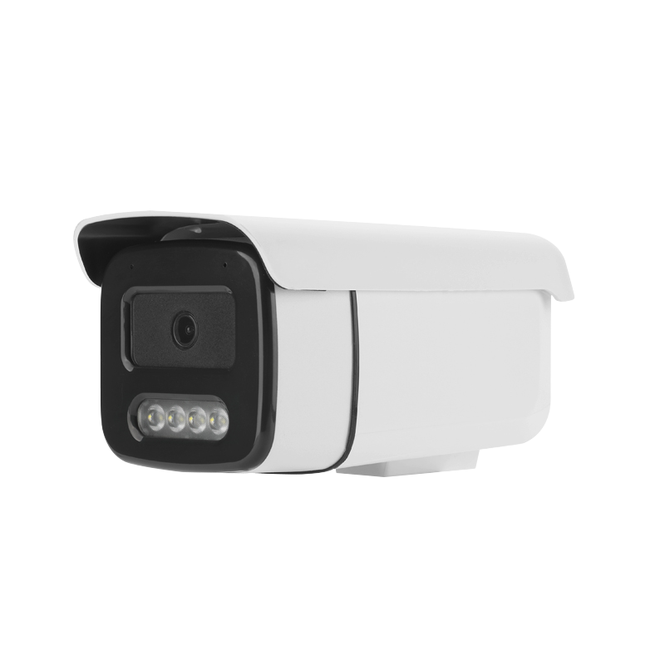
NexPro-BL1050M55-5MP-DIC · Primary

PRODUCT OVERVIEW
5MP full-color, compact design, dual-IC lamp, 8 LEDs, built-in mic, 4000V surge protection
Product line | CCTV & Surveillance System
Series / family | 1050
Exact model | NexPro-BL1050M55-5MP-DIC
Applications | Retail, Office, Small Perimeter
MODEL IDENTIFICATION
Exact model | Product / variant | Resolution | Lens | Illuminator
NexPro-BL1050M55-5MP-DIC | NexPro 5MP Compact Dual-Light Bullet (8-LED, Audio) | 5MP | F1.4 5MP fixed | 8-LED dual light
TECHNICAL SPECIFICATIONS
Parameter | Specification
Resolution | 5MP (2592×1944) @ real-time
Lens | F1.4 5MP fixed lens
Illuminator | 8-LED dual light (4×20mil IR + 4×0.5W warm white)
Camera Type | 5MP Compact Dual-Light Network Bullet Camera
Solution | Tianview TB38M55
Image Sensor | 1/2.7″ 5MP CMOS, low illumination
Lamp Board | Dual IC circuit design
Audio | Built-in microphone
Protection | Metal front cover, front heat dissipation, 4000V surge protection
Light Control | 3 switchable modes
Quotation Type | Bulk project quotation
OEM/ODM | Available for selected orders
Documents | Datasheet and installation reference
Category | CCTV System
APPLICATIONS & RFQ CONFIRMATION
Typical applications | Confirm in the project RFQ
Retail  Office  Small Perimeter | Confirm the exact model and required configuration.  Confirm quantity, destination, packing, branding, and documentation requirements.
Project supply: MOQ — Confirm by project quantity · Lead time — Confirm by project list · FOB port — China main ports · OEM/ODM — Available; confirm project scope
PROJECT CONFIGURATION CHECKLIST
Exact model | NexPro-BL1050M55-5MP-DIC
Application and site conditions | Confirm installation environment and operating requirements.
Quantity and model mix | Confirm forecast quantity, phase plan and required variants.
Interfaces and accessories | Confirm compatible interfaces, accessories and system integration scope.
Finish, branding and packing | Confirm only when project customization is required.
Documentation and destination | Confirm drawings, datasheets, packing documents and destination country or port.

