
CABLE & WIRE FOR ELECTRICAL, ELV AND INDUSTRIAL PROJECTS

Mining and Heavy-Duty Rubber Cable Series
  - Exact model: YC | YCW | MY | MYPTJ | MYPT | MCPT | MCP
PRODUCT IMAGES
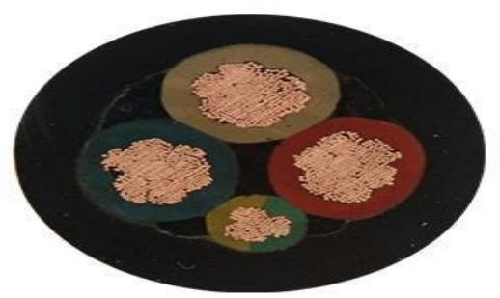 | 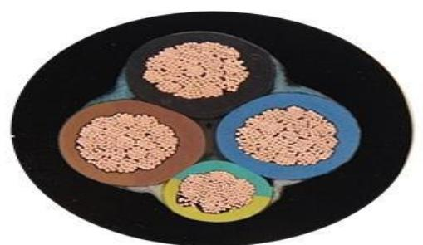 | 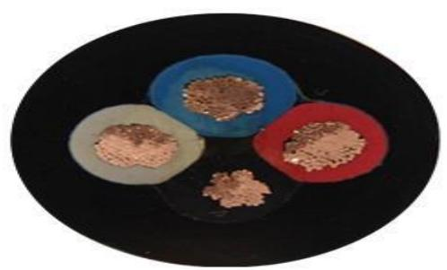 | 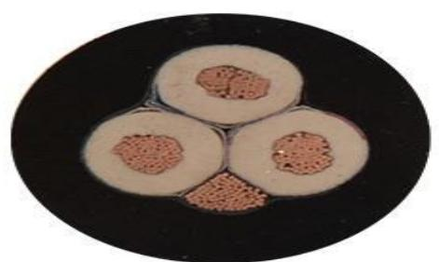
YC | YCW | MY | MYPTJ | MYPT | MCPT | MCP · Primary | YC | YCW | MY | MYPTJ | MYPT | MCPT | MCP · Gallery | YC | YCW | MY | MYPTJ | MYPT | MCPT | MCP · Gallery | YC | YCW | MY | MYPTJ | MYPT | MCPT | MCP · Gallery

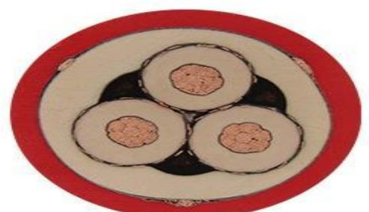 | 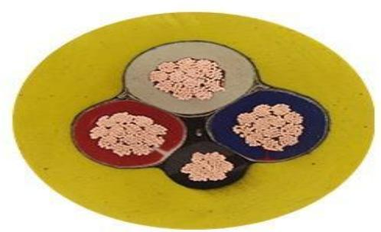 | 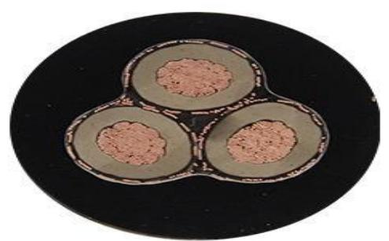 | 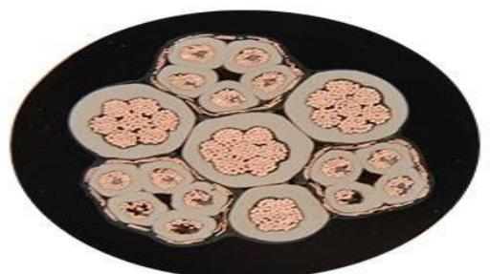
YC | YCW | MY | MYPTJ | MYPT | MCPT | MCP · Gallery | YC | YCW | MY | MYPTJ | MYPT | MCPT | MCP · Gallery | YC | YCW | MY | MYPTJ | MYPT | MCPT | MCP · Gallery | YC | YCW | MY | MYPTJ | MYPT | MCPT | MCP · Gallery

PRODUCT OVERVIEW
NexPro Mining and Heavy-Duty Rubber Cable Series is supplied as a configurable mining cable product family. Catalog models are preserved exactly as YC, YCW, MY, MYPTJ, MYPT, MCPT, MCP. Use the source-derived tables below to select the required conductor construction, core arrangement, cross-section and dimensions.
Product line | Cable & Wire for Electrical, ELV and Industrial Projects
Series / family | Mining cable
Exact model | YC | YCW | MY | MYPTJ | MYPT | MCPT | MCP
Applications | Industrial equipment, Mobile machinery, Demanding flexible installations
MODEL IDENTIFICATION
Exact model | Product / variant | Cable category | Catalog model | Configuration
YC | YCW | MY | MYPTJ | MYPT | MCPT | MCP | Mining and Heavy-Duty Rubber Cable Series | Mining cable | YC | YCW | MY | MYPTJ | MYPT | MCPT | MCP | Select from source table
TECHNICAL SPECIFICATIONS
Parameter | Specification
Cable category | Mining cable
Catalog model | YC | YCW | MY | MYPTJ | MYPT | MCPT | MCP
Configuration | Select from source table
Manufacturer models | YC / YCW / MY / MYPTJ / MYPT / MCPT / MCP
Specification status | No numeric source table was published for this product family
Selection guidance | Confirm the exact model, voltage rating, conductor or core configuration, cross-section, installation conditions, required length and applicable project requirements in the RFQ.
APPLICATIONS & RFQ CONFIRMATION
Typical applications | Confirm in the project RFQ
Industrial equipment  Mobile machinery  Demanding flexible installations | Confirm conductor material and construction, core count and cross-section.  Confirm voltage/model, installation method and environmental conditions.  Confirm required length, drum or coil packing, quantity and destination requirements.
Project supply: MOQ — Confirm by cable type, size and length · Lead time — Confirm after specification review · FOB port — Confirm in project quotation · OEM/ODM — To be confirmed
PROJECT CONFIGURATION CHECKLIST
Exact model | YC | YCW | MY | MYPTJ | MYPT | MCPT | MCP
Application and site conditions | Confirm installation environment and operating requirements.
Quantity and model mix | Confirm forecast quantity, phase plan and required variants.
Interfaces and accessories | Confirm compatible interfaces, accessories and system integration scope.
Finish, branding and packing | Confirm only when project customization is required.
Documentation and destination | Confirm drawings, datasheets, packing documents and destination country or port.

