
CABLE & WIRE FOR ELECTRICAL, ELV AND INDUSTRIAL PROJECTS

SPT-1 / SPT-2 / SPT-3 Lamp Cord
  - Exact model: SPT-1 | SPT-2 | SPT-3
PRODUCT IMAGES
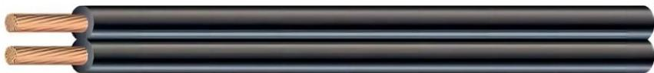 | 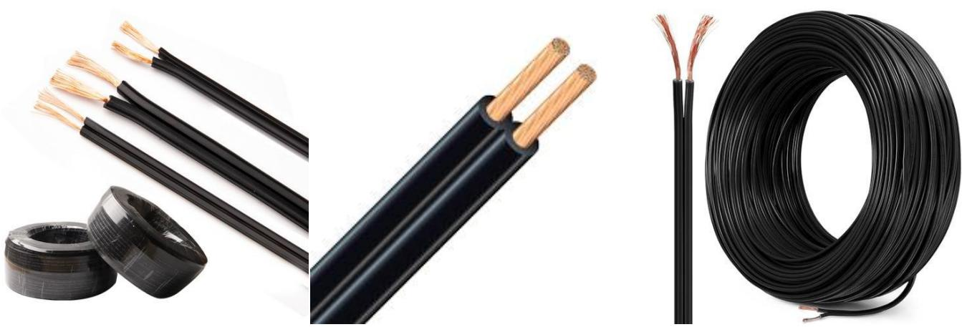
SPT-1 | SPT-2 | SPT-3 · Primary | SPT-1 | SPT-2 | SPT-3 · Gallery

PRODUCT OVERVIEW
NexPro SPT-1 / SPT-2 / SPT-3 Lamp Cord is supplied as a configurable lamp cord product family. Catalog models are preserved exactly as SPT-1, SPT-2, SPT-3. Use the source-derived tables below to select the required conductor construction, core arrangement, cross-section and dimensions.
Product line | Cable & Wire for Electrical, ELV and Industrial Projects
Series / family | Lamp cord
Exact model | SPT-1 | SPT-2 | SPT-3
Applications | Equipment connections, Flexible wiring, OEM electrical assemblies
MODEL IDENTIFICATION
Exact model | Product / variant | Cable category | Catalog model | Configuration
SPT-1 | SPT-2 | SPT-3 | SPT-1 / SPT-2 / SPT-3 Lamp Cord | Lamp cord | SPT-1 | SPT-2 | SPT-3 | Select from source table
TECHNICAL SPECIFICATIONS
Parameter | Specification
Cable category | Lamp cord
Catalog model | SPT-1 | SPT-2 | SPT-3
Configuration | Select from source table
Manufacturer models | SPT-1 / SPT-2 / SPT-3
SPT - 1 | Size  (AWG): — | No. of Conductors: — | Conductor Stranding (No./AWG): — | Insulation Thickness (inches): — | Overall Diameter (inches): — | Ampacity (amps): — | Weight (lbs/kft): —
SPT1-18/2 | Size  (AWG): 18 | No. of Conductors: 2 | Conductor Stranding (No./AWG): 41/34 | Insulation Thickness (inches): 0.030 | Overall Diameter (inches): 0.11 x 0.22 | Ampacity (amps): 10 | Weight (lbs/kft): 20
SPT1-18/3 | Size  (AWG): 18 | No. of Conductors: 3 | Conductor Stranding (No./AWG): 41/34 | Insulation Thickness (inches): 0.030 | Overall Diameter (inches): 0.11 x 0.33 | Ampacity (amps): 10 | Weight (lbs/kft): 30
SPT – 2 | Size  (AWG): — | No. of Conductors: — | Conductor Stranding (No./AWG): — | Insulation Thickness (inches): — | Overall Diameter (inches): — | Ampacity (amps): — | Weight (lbs/kft): —
SPT2-18/2 | Size  (AWG): 18 | No. of Conductors: 2 | Conductor Stranding (No./AWG): 41/34 | Insulation Thickness (inches): 0.045 | Overall Diameter (inches): 0.14 x 0.27 | Ampacity (amps): 10 | Weight (lbs/kft): 27
SPT2-16/2 | Size  (AWG): 16 | No. of Conductors: 2 | Conductor Stranding (No./AWG): 65/34 | Insulation Thickness (inches): 0.045 | Overall Diameter (inches): 0.15 x 0.30 | Ampacity (amps): 13 | Weight (lbs/kft): 36
SPT2-16/3 | Size  (AWG): 16 | No. of Conductors: 3 | Conductor Stranding (No./AWG): 65/34 | Insulation Thickness (inches): 0.045 | Overall Diameter (inches): 0.15 x 0.45 | Ampacity (amps): 10 | Weight (lbs/kft): 54
SPT – 3 | Size  (AWG): — | No. of Conductors: — | Conductor Stranding (No./AWG): — | Insulation Thickness (inches): — | Overall Diameter (inches): — | Ampacity (amps): — | Weight (lbs/kft): —
ENGINEERING TABLES
SPT-1 | SPT-2 | SPT-3 · Source Specification Table 1
Part Number | Size (AWG) | No. of Conductors | Conductor Stranding (No./AWG) | Insulation Thickness (inches) | Overall Diameter (inches) | Ampacity (amps) | Weight (lbs/kft)
SPT - 1 | — | — | — | — | — | — | —
SPT1-18/2 | 18 | 2 | 41/34 | 0.030 | 0.11 x 0.22 | 10 | 20
SPT1-18/3 | 18 | 3 | 41/34 | 0.030 | 0.11 x 0.33 | 10 | 30
SPT – 2 | — | — | — | — | — | — | —
SPT2-18/2 | 18 | 2 | 41/34 | 0.045 | 0.14 x 0.27 | 10 | 27
SPT2-16/2 | 16 | 2 | 65/34 | 0.045 | 0.15 x 0.30 | 13 | 36
SPT2-16/3 | 16 | 3 | 65/34 | 0.045 | 0.15 x 0.45 | 10 | 54
SPT – 3 | — | — | — | — | — | — | —
SPT3-16/2 | 16 | 2 | 65/34 | 0.060 | 0.18 x 0.36 | 13 | 47
SPT3-14/2 | 14 | 2 | 41/30 | 0.060 | 0.20 x 0.40 | 18 | 61
SPT3-14/3 | 14 | 3 | 41/30 | 0.060 | 0.20 x 0.60 | 15 | 92
SPT3-12/2 | 12 | 2 | 65/30 | 0.060 | 0.22 x 0.44 | 25 | 82
SPT3-12/3 | 12 | 3 | 65/30 | 0.060 | 0.22 x 0.66 | 20 | 123

