
CABLE & WIRE FOR ELECTRICAL, ELV AND INDUSTRIAL PROJECTS

NYY 0.6/1 kV PVC Power Cable
  - Models: NYY | N2XY-J | N2XY-O | N2XY-JZ | N2XY-OZ | VV
PRODUCT IMAGES
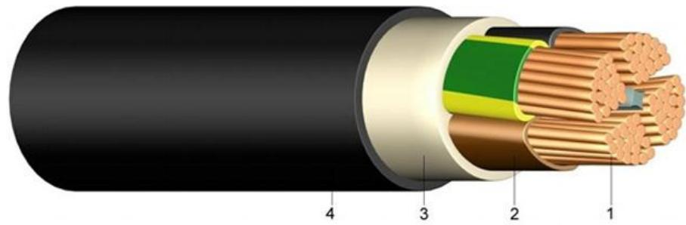 | 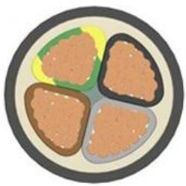 | 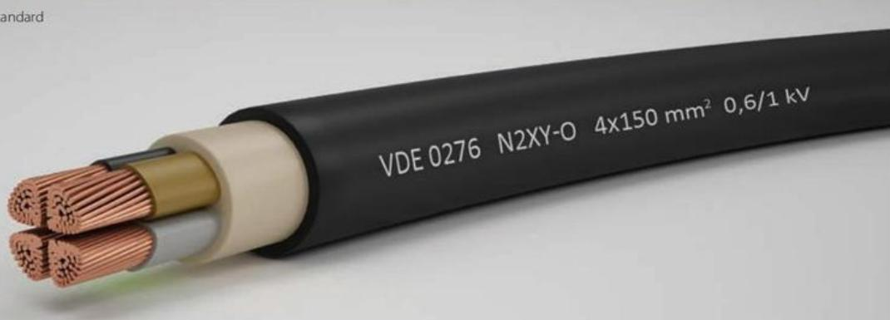 | 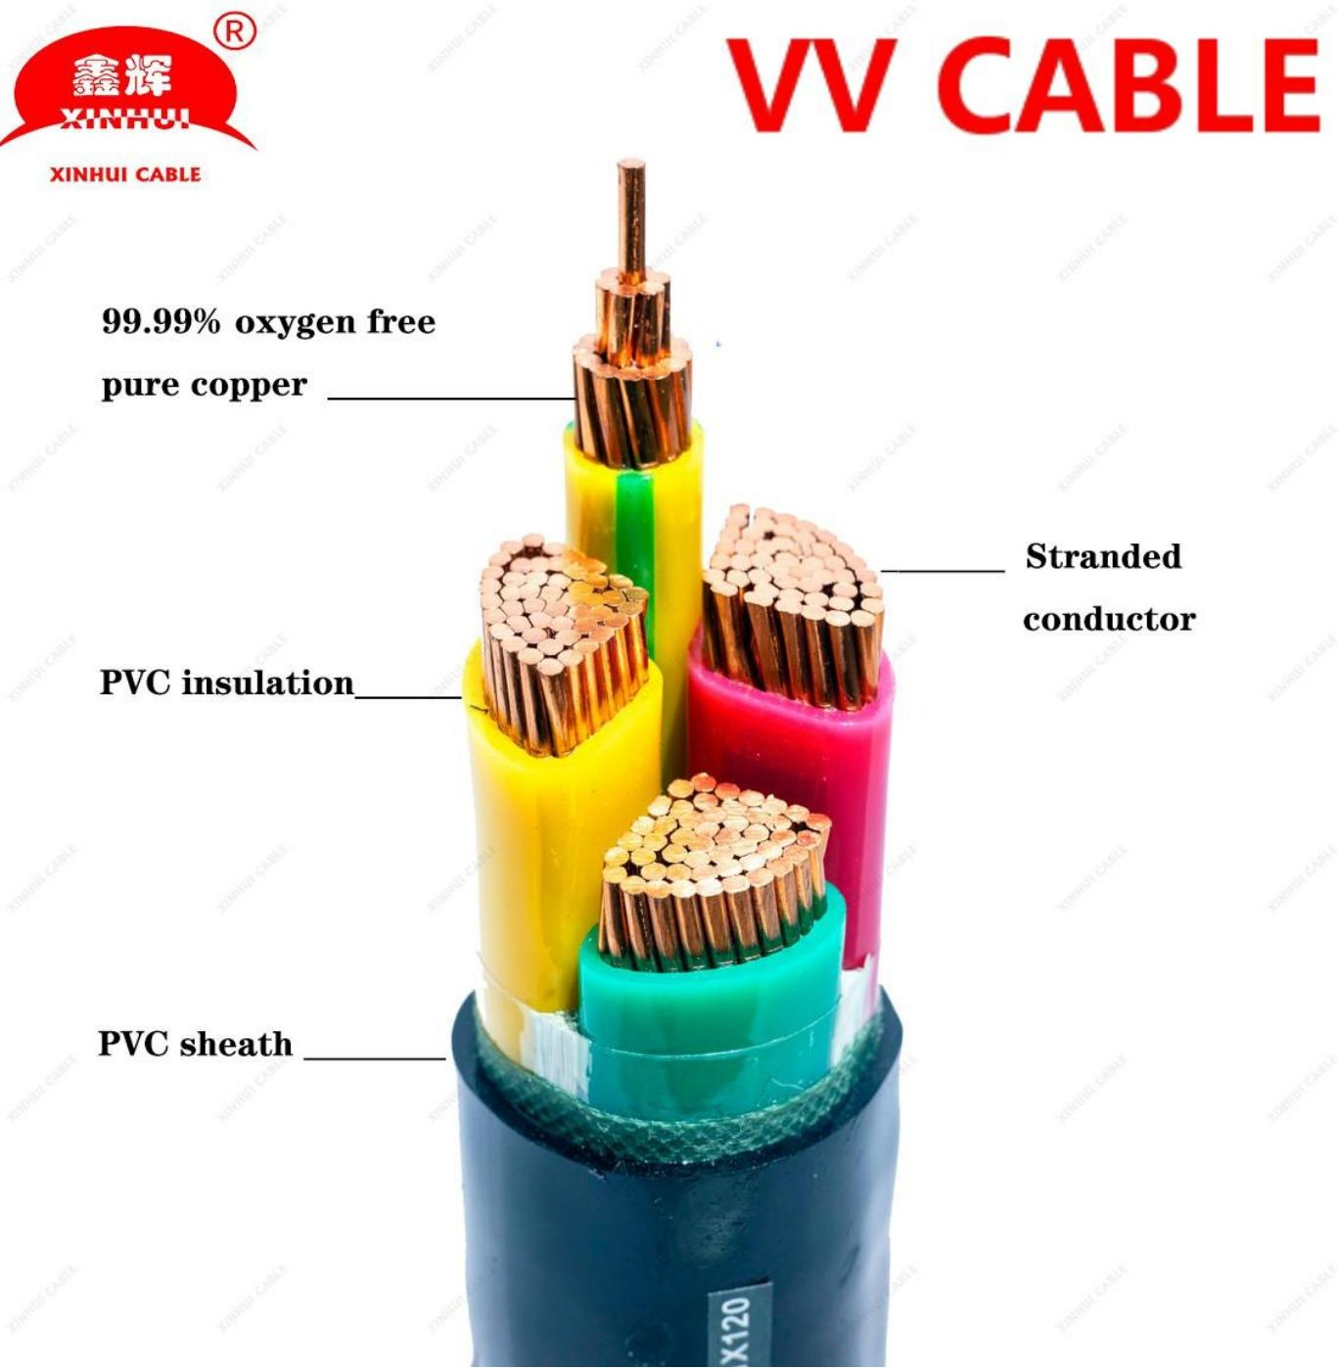
NYY · Primary | NYY · Gallery | N2XY-J | N2XY-O | N2XY-JZ | N2XY-OZ · Primary | VV · Primary

PRODUCT OVERVIEW
NexPro NYY 0.6/1 kV PVC Power Cable is supplied as a configurable low-voltage power cable product family. Catalog models are preserved exactly as NYY. Use the source-derived tables below to select the required conductor construction, core arrangement, cross-section and dimensions.
Product line | Cable & Wire for Electrical, ELV and Industrial Projects
Series / family | Low-voltage power cable
Exact model | NYY | N2XY-J | N2XY-O | N2XY-JZ | N2XY-OZ | VV
Applications | Low-voltage distribution, Industrial power projects, Fixed and buried installations
MODEL COMPARISON
Exact model | Product / variant | Cable category | Catalog model | Configuration
NYY | NYY 0.6/1 kV PVC Power Cable | Low-voltage power cable | NYY | Select from source table
N2XY-J | N2XY-O | N2XY-JZ | N2XY-OZ | N2XY 0.6/1 kV XLPE/PVC Power Cable | Low-voltage power cable | N2XY-J | N2XY-O | N2XY-JZ | N2XY-OZ | Select from source table
VV | VV PVC Insulated PVC Sheathed Power Cable | Low-voltage power cable | VV | Select from source table
TECHNICAL SPECIFICATIONS
Parameter | NYY | N2XY-J | N2XY-O | N2XY-JZ | N2XY-OZ | VV
Cable category | Low-voltage power cable | Low-voltage power cable | Low-voltage power cable
Catalog model | NYY | N2XY-J | N2XY-O | N2XY-JZ | N2XY-OZ | VV
Configuration | Select from source table | Select from source table | Select from source table
Manufacturer models | NYY | N2XY-J / N2XY-O / N2XY-JZ / N2XY-OZ | VV
Nominal voltage Uo/U | Specified value: | Value 2: [V] | Value 3: 600 / 1000 Volt | Not provided | Not provided
Test voltage | Specified value: | Value 2: [V]_{AC} | Value 3: 4000 | Not provided | Not provided
Temperature range | Specified value: in motion | Value 2: | Value 3: - 5°C till +70°C | Not provided | Not provided
fixed | Specified value: | Value 2: -20°C till +70°C | Value 3: — | Not provided | Not provided
Bending radius | Specified value: single-core style | Value 2: x diameter | Value 3: 15 | Not provided | Not provided
multi-core style | Specified value: x diameter | Value 2: 12 | Value 3: — | Not provided | Not provided
Flammability | Specified value: standard | Value 2: | Value 3: EN 60332-1-2 | Not provided | Not provided
Source parameter | Not provided | With protective conductor: N2XY-J | Without protective conductor: N2XY-O; With protective conductor: N2XY-JZ | Without protective conductor: N2XY-OZ | Not provided
1 | Not provided | With protective conductor: gn/ye | Without protective conductor: bk | Not provided
2 | Not provided | With protective conductor: - | Without protective conductor: bu, bn | Not provided
3 | Not provided | With protective conductor: gn/ye, bu, bn | Without protective conductor: bn, bk, gy | Not provided
4 | Not provided | With protective conductor: gn/ye, bn, bk, gy | Without protective conductor: bu, bn, bk, gy | Not provided
5 | Not provided | With protective conductor: gn/ye, bu, bn, bk, gy | Without protective conductor: bu, bn, bk, gy, bk | Not provided
>5 | Not provided | With protective conductor: gn/ye, black cores with white numbering | Without protective conductor: black cores with white numbering | Not provided
Specification status | Not provided | Not provided | No numeric source table was published for this product family
Selection guidance | Not provided | Not provided | Confirm the exact model, voltage rating, conductor or core configuration, cross-section, installation conditions, required length and applicable project requirements in the RFQ.
ENGINEERING TABLES
NYY · Technical data:
Parameter | Specified value | Value 2 | Value 3
Nominal voltage Uo/U | Not provided | [V] | 600 / 1000 Volt
Test voltage | Not provided | [V]_{AC} | 4000
Temperature range | in motion | Not provided | - 5°C till +70°C
fixed | Not provided | -20°C till +70°C | —
Bending radius | single-core style | x diameter | 15
multi-core style | x diameter | 12 | —
Flammability | standard | Not provided | EN 60332-1-2
NYY · Source Specification Table 2
Number of cores and nominal cross section | Copper figure | Overall diameter | Weight | Current carrying capacity ground | Current carrying capacity air
mm^2 | kg/km | appr. mm | kg/km | A | A
1 x 4 RE | 38,4 | 8 | 120 | 50 | 37
1 x 6 RE | 57,6 | 9 | 131 | 62 | 47
1 x 10 RE | 96,0 | 10 | 171 | 83 | 64
1 x 16 RE | 153,6 | 11 | 233 | 107 | 84
1 x 25 RM | 240,0 | 12 | 370 | 138 | 114
1 x 35 RM | 336,0 | 14 | 480 | 164 | 139
1 x 50 RM | 480,0 | 16 | 640 | 195 | 169
1 x 70 RM | 672,0 | 17 | 850 | 238 | 213
1 x 95 RM | 912,0 | 19 | 1.120 | 286 | 264
1 x 120 RM | 1.152,0 | 21 | 1.375 | 325 | 307
1 x 150 RM | 1.440,0 | 23 | 1.660 | 365 | 352
1 x 185 RM | 1.776,0 | 25 | 2.050 | 413 | 406
1 x 240 RM | 2.304,0 | 28 | 2.634 | 479 | 483
1 x 300 RM | 2.880,0 | 30 | 3.295 | 541 | 557
N2XY-J | N2XY-O | N2XY-JZ | N2XY-OZ · Source Specification Table 1
Number of cores | With protective conductor | Without protective conductor
Not provided | N2XY-J | N2XY-O
1 | gn/ye | bk
2 | - | bu, bn
3 | gn/ye, bu, bn | bn, bk, gy
4 | gn/ye, bn, bk, gy | bu, bn, bk, gy
5 | gn/ye, bu, bn, bk, gy | bu, bn, bk, gy, bk
Not provided | N2XY-JZ | N2XY-OZ
>5 | gn/ye, black cores with white numbering | black cores with white numbering

