
CABLE & WIRE FOR ELECTRICAL, ELV AND INDUSTRIAL PROJECTS

NHXH E90 Halogen-Free Fire-Resistant Cable
  - Exact model: NHXH E90
PRODUCT IMAGES
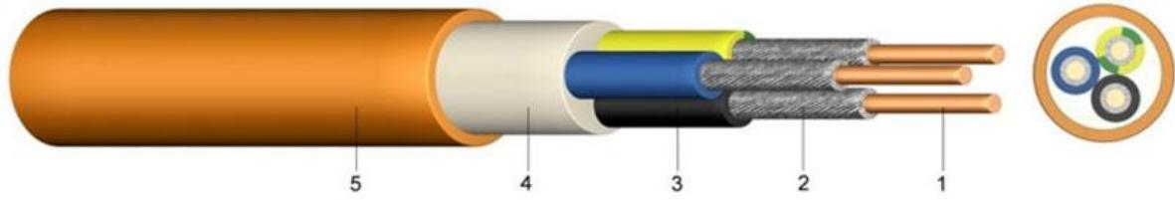
NHXH E90 · Primary

PRODUCT OVERVIEW
NexPro NHXH E90 Halogen-Free Fire-Resistant Cable is supplied as a configurable fire-resistant safety cable product family. Catalog models are preserved exactly as NHXH E90. Use the source-derived tables below to select the required conductor construction, core arrangement, cross-section and dimensions.
Product line | Cable & Wire for Electrical, ELV and Industrial Projects
Series / family | Fire-resistant safety cable
Exact model | NHXH E90
Applications | Public buildings, Emergency circuits, Low-smoke installation projects
MODEL IDENTIFICATION
Exact model | Product / variant | Cable category | Catalog model | Configuration
NHXH E90 | NHXH E90 Halogen-Free Fire-Resistant Cable | Fire-resistant safety cable | NHXH E90 | Select from source table
TECHNICAL SPECIFICATIONS
Parameter | Specification
Cable category | Fire-resistant safety cable
Catalog model | NHXH E90
Configuration | Select from source table
Manufacturer models | NHXH E90
Test voltage | Column 2: | [V]: [V]_{AC} | 600 / 1000 Volt: 4000
Temperature range | Column 2: in motion | [V]: | 600 / 1000 Volt: -5°C till +90°C
Operating temperature | Column 2: short circuit | [V]: °C | 600 / 1000 Volt: 250
Short circuit time | Column 2: max. | [V]: [sec] | 600 / 1000 Volt: 5
Bending radius | Column 2: single core style | [V]: x diameter | 600 / 1000 Volt: 15
multi core style | Column 2: x diameter | [V]: 12 | 600 / 1000 Volt: —
Flammability | Column 2: standard | [V]: | 600 / 1000 Volt: EN 50266-2-4IEC 60332-3 Kat.C
ENGINEERING TABLES
NHXH E90 · Source Specification Table 1
Nominal voltage Uo/U | Column 2 | [V] | 600 / 1000 Volt
Test voltage | Not provided | [V]_{AC} | 4000
Temperature range | in motion | Not provided | -5°C till +90°C
Operating temperature | short circuit | °C | 250
Short circuit time | max. | [sec] | 5
Bending radius | single core style | x diameter | 15
multi core style | x diameter | 12 | —
Flammability | standard | Not provided | EN 50266-2-4IEC 60332-3 Kat.C
NHXH E90 · Source Specification Table 2
Number of cores and nominal cross section mm^2 | Copper figure kg/km | Overall diameter appr.mm | Calorific potential kWh/m | Weight appr. kg/km
1 x 16 RM | 160 | 10,5 | 0,42 | 250
1 x 25 RM | 250 | 12,5 | 0,53 | 355
1 x 35 RM | 350 | 13,5 | 0,60 | 460
1 x 50 RM | 500 | 15,0 | 0,69 | 596
1 x 70 RM | 700 | 16,5 | 0,83 | 810
1 x 95 RM | 950 | 19,0 | 1,06 | 1.100
1 x 120 RM | 1.200 | 20,5 | 1,15 | 1.350

