
CABLE & WIRE FOR ELECTRICAL, ELV AND INDUSTRIAL PROJECTS

H05Z-R / H07Z-R LSZH Insulated Wire
  - Models: H05Z-R | H07Z-R | H07Z1-U
PRODUCT IMAGES
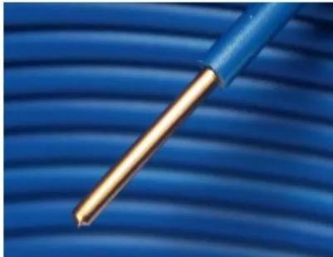 | 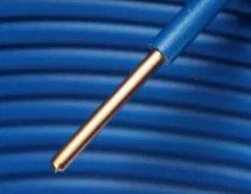
H05Z-R | H07Z-R · Primary | H07Z1-U · Primary

PRODUCT OVERVIEW
NexPro H05Z-R / H07Z-R LSZH Insulated Wire is supplied as a configurable low-smoke zero-halogen wire product family. Catalog models are preserved exactly as H05Z-R, H07Z-R. Use the source-derived tables below to select the required conductor construction, core arrangement, cross-section and dimensions.
Product line | Cable & Wire for Electrical, ELV and Industrial Projects
Series / family | Low-smoke zero-halogen wire
Exact model | H05Z-R | H07Z-R | H07Z1-U
Applications | Public buildings, Emergency circuits, Low-smoke installation projects
MODEL COMPARISON
Exact model | Product / variant | Cable category | Catalog model | Configuration
H05Z-R | H07Z-R | H05Z-R / H07Z-R LSZH Insulated Wire | Low-smoke zero-halogen wire | H05Z-R | H07Z-R | Select from source table
H07Z1-U | H07Z1-U LSZH Solid Building Wire | Low-smoke zero-halogen wire | H07Z1-U | Select from source table
TECHNICAL SPECIFICATIONS
Parameter | H05Z-R | H07Z-R | H07Z1-U
Cable category | Low-smoke zero-halogen wire | Low-smoke zero-halogen wire
Catalog model | H05Z-R | H07Z-R | H07Z1-U
Configuration | Select from source table | Select from source table
Manufacturer models | H05Z-R / H07Z-R | H07Z1-U
Specification status | No numeric source table was published for this product family | Not provided
Selection guidance | Confirm the exact model, voltage rating, conductor or core configuration, cross-section, installation conditions, required length and applicable project requirements in the RFQ. | Not provided
1.5 | Not provided | Nominal Thickness of insulation  (mm): 0.7 | MAX. Resistance of conductor at 70°C (MΩ): 0.011 | Nom. outer diam. (mm): 2.6-3.2 | Approx. weight (kg/km): 21
2.5 | Not provided | Nominal Thickness of insulation  (mm): 0.8 | MAX. Resistance of conductor at 70°C (MΩ): 0.010 | Nom. outer diam. (mm): 3.2-3.9 | Approx. weight (kg/km): 35
4 | Not provided | Nominal Thickness of insulation  (mm): 0.8 | MAX. Resistance of conductor at 70°C (MΩ): 0.0087 | Nom. outer diam. (mm): 3.6-4.4 | Approx. weight (kg/km): 44
6 | Not provided | Nominal Thickness of insulation  (mm): 0.8 | MAX. Resistance of conductor at 70°C (MΩ): 0.0074 | Nom. outer diam. (mm): 4.1-5.0 | Approx. weight (kg/km): 66
ENGINEERING TABLES
H07Z1-U · Source Specification Table 1
Cross section (mm²) | Nominal Thickness of insulation (mm) | MAX. Resistance of conductor at 70°C (MΩ) | Nom. outer diam. (mm) | Approx. weight (kg/km)
1.5 | 0.7 | 0.011 | 2.6-3.2 | 21
2.5 | 0.8 | 0.010 | 3.2-3.9 | 35
4 | 0.8 | 0.0087 | 3.6-4.4 | 44
6 | 0.8 | 0.0074 | 4.1-5.0 | 66

