
CABLE & WIRE FOR ELECTRICAL, ELV AND INDUSTRIAL PROJECTS

H05V-U / H07V-U PVC Insulated Solid Building Wire
  - Models: H05V-U | H07V-U | H05V-R | H07V-R
PRODUCT IMAGES
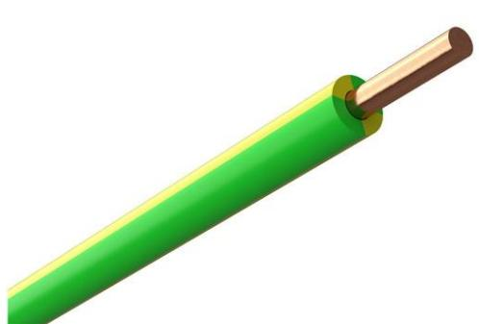 | 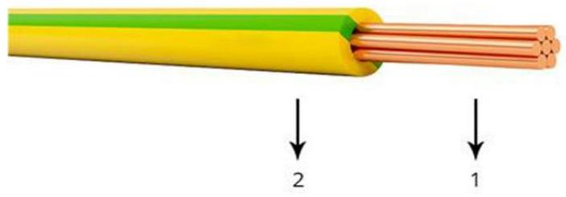
H05V-U | H07V-U · Primary | H05V-R | H07V-R · Primary

PRODUCT OVERVIEW
NexPro H05V-U / H07V-U PVC Insulated Solid Building Wire is supplied as a configurable single-core building wire product family. Catalog models are preserved exactly as H05V-U, H07V-U. Use the source-derived tables below to select the required conductor construction, core arrangement, cross-section and dimensions.
Product line | Cable & Wire for Electrical, ELV and Industrial Projects
Series / family | Single-core building wire
Exact model | H05V-U | H07V-U | H05V-R | H07V-R
Applications | Building wiring, Electrical panels, Fixed installation projects
MODEL COMPARISON
Exact model | Product / variant | Cable category | Catalog model | Configuration
H05V-U | H07V-U | H05V-U / H07V-U PVC Insulated Solid Building Wire | Single-core building wire | H05V-U | H07V-U | Select from source table
H05V-R | H07V-R | H05V-R / H07V-R PVC Insulated Stranded Building Wire | Single-core building wire | H05V-R | H07V-R | Select from source table
TECHNICAL SPECIFICATIONS
Parameter | H05V-U | H07V-U | H05V-R | H07V-R
Cable category | Single-core building wire | Single-core building wire
Catalog model | H05V-U | H07V-U | H05V-R | H07V-R
Configuration | Select from source table | Select from source table
Manufacturer models | H05V-U / H07V-U | H05V-R / H07V-R
Conductor | Specified value: Bare solid copper | Not provided
Insulation | Specified value: PVC | Not provided
Minimum bending radius, fixed installation | Specified value: 4xOD | Not provided
Colour | Specified value: According to EN 50525-1 | Not provided
Specification status | Not provided | No numeric source table was published for this product family
Selection guidance | Not provided | Confirm the exact model, voltage rating, conductor or core configuration, cross-section, installation conditions, required length and applicable project requirements in the RFQ.
ENGINEERING TABLES
H05V-U | H07V-U · Construction
Parameter | Specified value
Conductor | Bare solid copper
Insulation | PVC
Minimum bending radius, fixed installation | 4xOD
Colour | According to EN 50525-1
H05V-U | H07V-U · Source Specification Table 2
Type Code | Cross-section [mm] | Nominal Outer Diameter [mm] | Current rating, installation in open air, ambient 30°C [A] | Total weight [kg/km]
H05V-U | 0,5 | 2,0 | 12 | 9
H05V-U | 0,75 | 2,2 | 15 | 11
H05V-U | 1 | 2,3 | 19 | 14
H07V-U | 1,5 | 2,8 | 24 | 20
H07V-U | 2,5 | 3,4 | 32 | 31
H07V-U | 4 | 3,8 | 42 | 46
H07V-U | 6 | 4,3 | 54 | 68
H07V-U | 10 | 5,4 | 73 | 111

