
CABLE & WIRE FOR ELECTRICAL, ELV AND INDUSTRIAL PROJECTS

H05V-K Flexible PVC Insulated Wire
  - Models: H05V-K | H07V-K
PRODUCT IMAGES
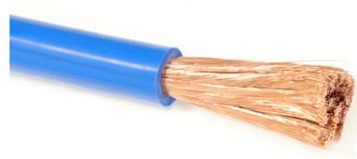 | 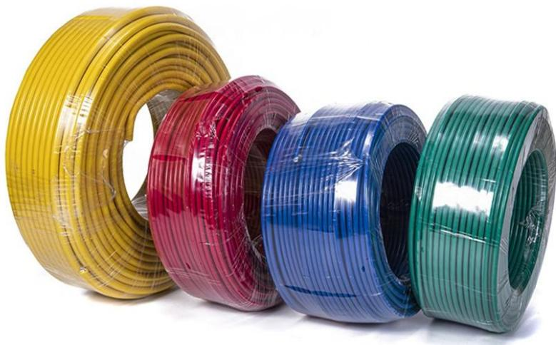 | 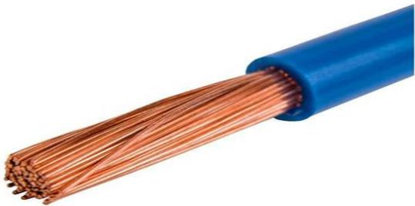 | 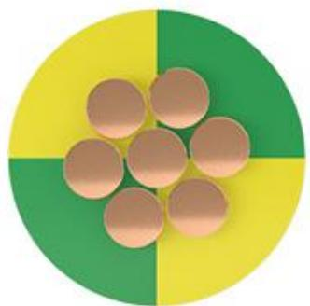
H05V-K · Primary | H05V-K · Gallery | H07V-K · Primary | H07V-K · Gallery

PRODUCT OVERVIEW
NexPro H05V-K Flexible PVC Insulated Wire is supplied as a configurable single-core flexible wire product family. Catalog models are preserved exactly as H05V-K. Use the source-derived tables below to select the required conductor construction, core arrangement, cross-section and dimensions.
Product line | Cable & Wire for Electrical, ELV and Industrial Projects
Series / family | Single-core flexible wire
Exact model | H05V-K | H07V-K
Applications | Equipment connections, Flexible wiring, OEM electrical assemblies
MODEL COMPARISON
Exact model | Product / variant | Cable category | Catalog model | Configuration
H05V-K | H05V-K Flexible PVC Insulated Wire | Single-core flexible wire | H05V-K | Select from source table
H07V-K | H07V-K Flexible PVC Insulated Wire | Single-core flexible wire | H07V-K | Select from source table
TECHNICAL SPECIFICATIONS
Parameter | H05V-K | H07V-K
Cable category | Single-core flexible wire | Single-core flexible wire
Catalog model | H05V-K | H07V-K
Configuration | Select from source table | Select from source table
Manufacturer models | H05V-K | H07V-K
1x0,5 | Resistance at 20 °C  (Ohm/km): 39 | External Diameter (mm): 2,15 | Weight (kg/km): 9 | Class: Eca | Not provided
1x0,75 | Resistance at 20 °C  (Ohm/km): 26 | External Diameter (mm): 2,25 | Weight (kg/km): 11 | Class: Eca | Not provided
1x1 | Resistance at 20 °C  (Ohm/km): 19,5 | External Diameter (mm): 2,50 | Weight (kg/km): 14 | Class: Eca | Not provided
1.5 | Not provided | Conductor diam.  (mm): 1.55 | Nom. o u t e r d i a m . (mm): 3.50 | Permissible current rating (3 conductors) (A): 15.5 | Permissible current (One phase) (A): 17.5 | Approx. weight (kg/km): 21
2.5 | Not provided | Conductor diam.  (mm): 2.00 | Nom. o u t e r d i a m . (mm): 4.2 | Permissible current rating (3 conductors) (A): 21.0 | Permissible current (One phase) (A): 24.0 | Approx. weight (kg/km): 35
4 | Not provided | Conductor diam.  (mm): 2.50 | Nom. o u t e r d i a m . (mm): 4.8 | Permissible current rating (3 conductors) (A): 28.0 | Permissible current (One phase) (A): 32.0 | Approx. weight (kg/km): 45
6 | Not provided | Conductor diam.  (mm): 3.00 | Nom. o u t e r d i a m . (mm): 6.3 | Permissible current rating (3 conductors) (A): 36.0 | Permissible current (One phase) (A): 41.0 | Approx. weight (kg/km): 68
10 | Not provided | Conductor diam.  (mm): 4.00 | Nom. o u t e r d i a m . (mm): 7.6 | Permissible current rating (3 conductors) (A): 50.0 | Permissible current (One phase) (A): 57.0 | Approx. weight (kg/km): 115
16 | Not provided | Conductor diam.  (mm): 5.45 | Nom. o u t e r d i a m . (mm): 8.8 | Permissible current rating (3 conductors) (A): 68.0 | Permissible current (One phase) (A): 76.0 | Approx. weight (kg/km): 183
25 | Not provided | Conductor diam.  (mm): 6.60 | Nom. o u t e r d i a m . (mm): 11.0 | Permissible current rating (3 conductors) (A): 89.0 | Permissible current (One phase) (A): 96.0 | Approx. weight (kg/km): 290
35 | Not provided | Conductor diam.  (mm): 8.00 | Nom. o u t e r d i a m . (mm): 12.5 | Permissible current rating (3 conductors) (A): 110.0 | Permissible current (One phase) (A): 119.0 | Approx. weight (kg/km): 320
ENGINEERING TABLES
H05V-K · Source Specification Table 1
Section (mm²) | Resistance at 20 °C (Ohm/km) | External Diameter (mm) | Weight (kg/km) | Class
1x0,5 | 39 | 2,15 | 9 | Eca
1x0,75 | 26 | 2,25 | 11 | Eca
1x1 | 19,5 | 2,50 | 14 | Eca
H05V-K · Source Specification Table 2
1. Conductor | Flexible electrolytic copper conductor (Class V) according to BS EN 60228:2005 (previously BS6360) and EN 60228.
2. Insulation | PVC insulation type TI-1 according to BS7655 and HD 21.3S3:1995/A2:2008.
Nominal voltage | 300/500 V
Test voltage | 2.000 V A.C.
Maximum temperature | 70 °C
Other characteristics | —
Colours according to HD 21.1S4:2002Non-flame propagating according to UNE-EN 60332-1-2, EN 60332-1-2 and IEC 60332-1-2CPR Classification according to EN 50575 | —
H07V-K · Source Specification Table 1
Cross section (mm²) | Conductor diam. (mm) | Nom. o u t e r d i a m . (mm) | Permissible current rating (3 conductors) (A) | Permissible current (One phase) (A) | Approx. weight (kg/km)
1.5 | 1.55 | 3.50 | 15.5 | 17.5 | 21
2.5 | 2.00 | 4.2 | 21.0 | 24.0 | 35
4 | 2.50 | 4.8 | 28.0 | 32.0 | 45
6 | 3.00 | 6.3 | 36.0 | 41.0 | 68
10 | 4.00 | 7.6 | 50.0 | 57.0 | 115
16 | 5.45 | 8.8 | 68.0 | 76.0 | 183
25 | 6.60 | 11.0 | 89.0 | 96.0 | 290
35 | 8.00 | 12.5 | 110.0 | 119.0 | 320
50 | 9.50 | 14.5 | 134.0 | 144.0 | 470
70 | 11.30 | 17.0 | 171.0 | 184.0 | 505
95 | 13.60 | 19.0 | 207.0 | 223.0 | 756
120 | 15.20 | 21.0 | 239.0 | 259.0 | 1120
150 | 16.70 | 23.5 | 275.0 | 299.0 | 1525
185 | 18.80 | 26.0 | 315.0 | 341.0 | 1890
240 | 21.20 | 29.5 | 371.0 | 403.0 | 2340

