
CABLE & WIRE FOR ELECTRICAL, ELV AND INDUSTRIAL PROJECTS

H03VV-F Light Duty PVC Flexible Cord
  - Models: H03VV-F | H05VV-F | 60227 IEC 53 (RVV) | RVV
PRODUCT IMAGES
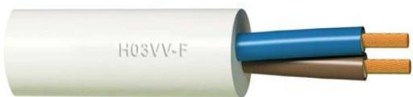 | 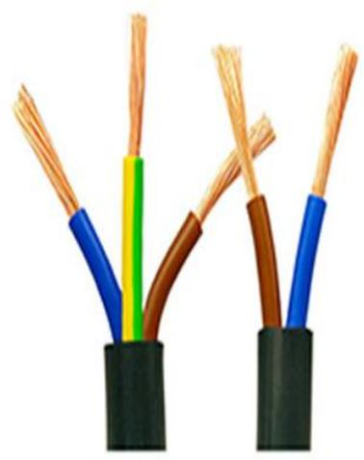 | 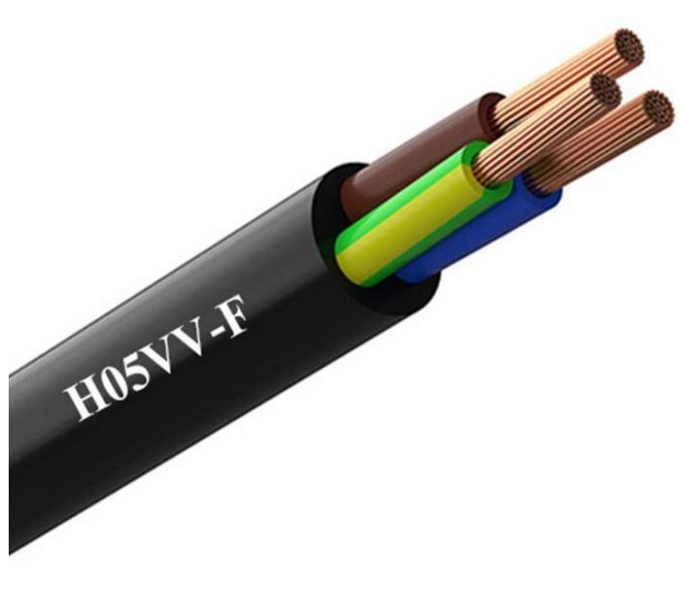 | 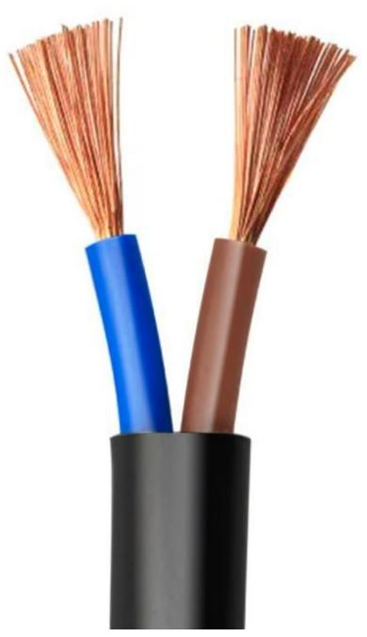
H03VV-F · Primary | H05VV-F · Primary | H05VV-F · Gallery | H05VV-F · Gallery

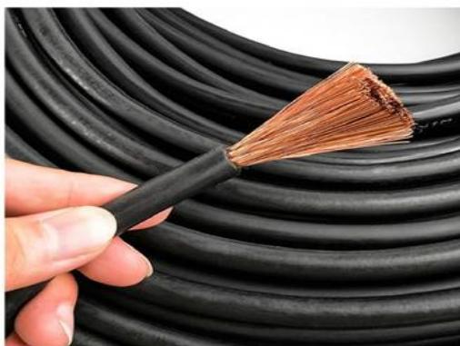 | 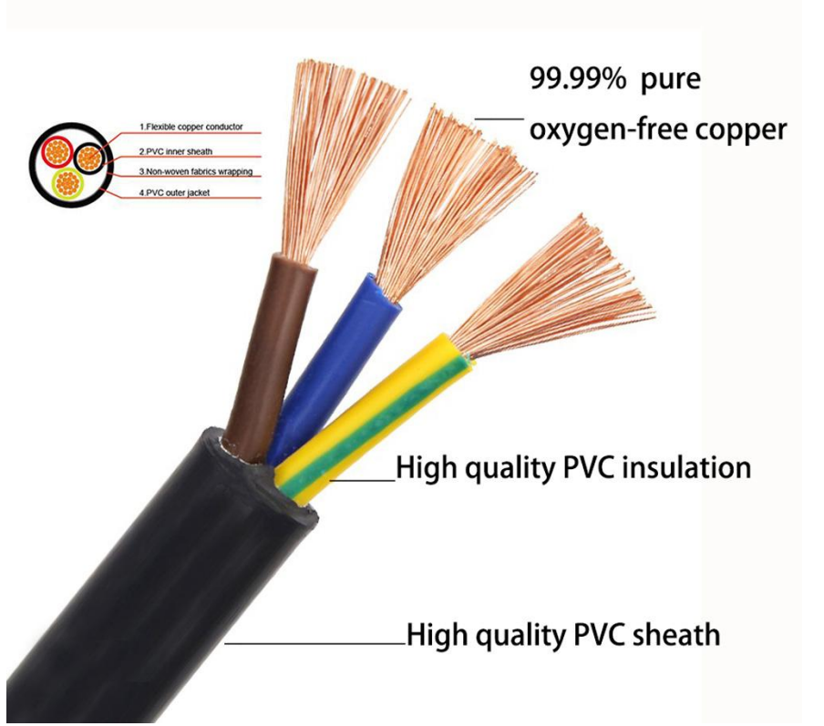
H05VV-F · Gallery | 60227 IEC 53 (RVV) | RVV · Primary

PRODUCT OVERVIEW
NexPro H03VV-F Light Duty PVC Flexible Cord is supplied as a configurable pvc flexible cord product family. Catalog models are preserved exactly as H03VV-F. Use the source-derived tables below to select the required conductor construction, core arrangement, cross-section and dimensions.
Product line | Cable & Wire for Electrical, ELV and Industrial Projects
Series / family | PVC flexible cord
Exact model | H03VV-F | H05VV-F | 60227 IEC 53 (RVV) | RVV
Applications | Equipment connections, Flexible wiring, OEM electrical assemblies
MODEL COMPARISON
Exact model | Product / variant | Cable category | Catalog model | Configuration
H03VV-F | H03VV-F Light Duty PVC Flexible Cord | PVC flexible cord | H03VV-F | Select from source table
H05VV-F | H05VV-F Ordinary Duty PVC Flexible Cable | PVC flexible cord | H05VV-F | Select from source table
60227 IEC 53 (RVV) | RVV | RVV PVC Insulated Flexible Sheathed Cable | PVC flexible cord | 60227 IEC 53 (RVV) | RVV | Select from source table
TECHNICAL SPECIFICATIONS
Parameter | H03VV-F | H05VV-F | 60227 IEC 53 (RVV) | RVV
Cable category | PVC flexible cord | PVC flexible cord | PVC flexible cord
Catalog model | H03VV-F | H05VV-F | 60227 IEC 53 (RVV) | RVV
Configuration | Select from source table | Select from source table | Select from source table
Manufacturer models | H03VV-F | H05VV-F | 60227 IEC 53 (RVV) / RVV
2x0,5 | Resistance at 20 °C  (Ohm/km): 39 | External Diameter (mm): 4,75 | Weight (kg/km): 40 | Class: Eca | Not provided | Not provided
2x0,75 | Resistance at 20 °C  (Ohm/km): 26 | External Diameter (mm): 5,20 | Weight (kg/km): 41 | Class: Eca | Not provided | Not provided
3G0,5 | Resistance at 20 °C  (Ohm/km): 39 | External Diameter (mm): 5,25 | Weight (kg/km): 42 | Class: Eca | Not provided | Not provided
3G0,75 | Resistance at 20 °C  (Ohm/km): 26 | External Diameter (mm): 5,50 | Weight (kg/km): 49 | Class: Eca | Not provided | Not provided
4x0,5 | Resistance at 20 °C  (Ohm/km): 39 | External Diameter (mm): 5,60 | Weight (kg/km): 47 | Class: Eca | Not provided | Not provided
4x0,75 | Resistance at 20 °C  (Ohm/km): 26 | External Diameter (mm): 6,30 | Weight (kg/km): 64 | Class: Eca | Not provided | Not provided
Specification status | Not provided | No numeric source table was published for this product family | No numeric source table was published for this product family
Selection guidance | Not provided | Confirm the exact model, voltage rating, conductor or core configuration, cross-section, installation conditions, required length and applicable project requirements in the RFQ. | Confirm the exact model, voltage rating, conductor or core configuration, cross-section, installation conditions, required length and applicable project requirements in the RFQ.
ENGINEERING TABLES
H03VV-F · Source Specification Table 1
Section (mm²) | Resistance at 20 °C (Ohm/km) | External Diameter (mm) | Weight (kg/km) | Class
2x0,5 | 39 | 4,75 | 40 | Eca
2x0,75 | 26 | 5,20 | 41 | Eca
3G0,5 | 39 | 5,25 | 42 | Eca
3G0,75 | 26 | 5,50 | 49 | Eca
4x0,5 | 39 | 5,60 | 47 | Eca
4x0,75 | 26 | 6,30 | 64 | Eca
H03VV-F · Source Specification Table 2
1. Conductor | Flexible electrolytic copper conductor (Class V) according to BS EN 60228:2005 (previously BS6360) and UNE 60228.
2. Insulation | PVC insulation type TI-2 according to BS7655, UNE-EN 50363-3 and EN 50363-3
3. Sheath | PVC sheath type TM-2 according to BS7655, UNE-EN 50363-4-1 and EN 50363-4-1
Nominal voltage | 300/300 V
Test voltage | 2.000 V A.C.
Maximum temperature | 70 °C
Other characteristics | —
Colours according to UNE 21089 and HD 303S2 (colour marking when less than five conductors) and UNE-EN 50334 and EN 50334 (inscription marking when more than five conductors)Non-flame propagating according to UNE-EN 60332-1-2, EN 60332-1-2 and IEC 60332-1-2PVC with reduced hydrogen chloride (HCI) emissionCPR Classification according to EN 50575 | —

