
CABLE & WIRE FOR ELECTRICAL, ELV AND INDUSTRIAL PROJECTS

H01N2-D Welding Cable
  - Models: H01N2-D | H05RR-F | H05RN-F | H07RN-F
PRODUCT IMAGES
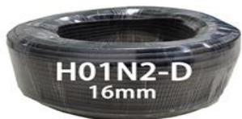 | 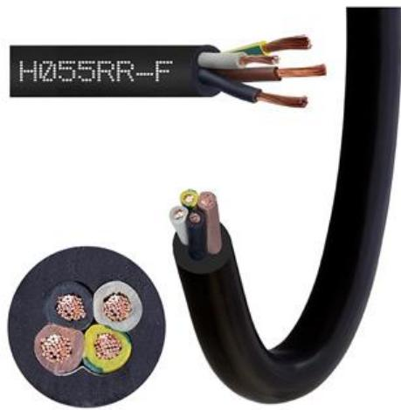 | 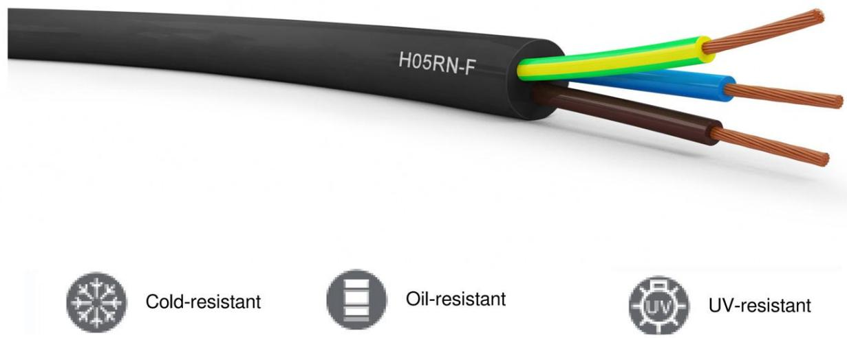 | 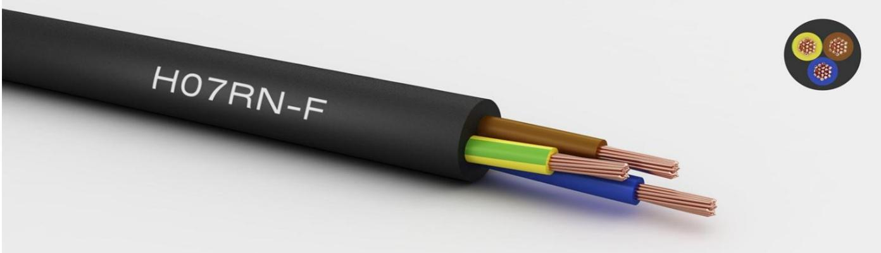
H01N2-D · Primary | H05RR-F · Primary | H05RN-F · Primary | H07RN-F · Primary

PRODUCT OVERVIEW
NexPro H01N2-D Welding Cable is supplied as a configurable rubber flexible cable product family. Catalog models are preserved exactly as H01N2-D. Use the source-derived tables below to select the required conductor construction, core arrangement, cross-section and dimensions.
Product line | Cable & Wire for Electrical, ELV and Industrial Projects
Series / family | Rubber flexible cable
Exact model | H01N2-D | H05RR-F | H05RN-F | H07RN-F
Applications | Industrial equipment, Mobile machinery, Demanding flexible installations
MODEL COMPARISON
Exact model | Product / variant | Cable category | Catalog model | Configuration
H01N2-D | H01N2-D Welding Cable | Rubber flexible cable | H01N2-D | Select from source table
H05RR-F | H05RR-F Ordinary Duty Rubber Cable | Rubber flexible cable | H05RR-F | Select from source table
H05RN-F | H05RN-F Oil-Resistant Rubber Cable | Rubber flexible cable | H05RN-F | Select from source table
H07RN-F | H07RN-F Heavy Duty Rubber Trailing Cable | Rubber flexible cable | H07RN-F | Select from source table
TECHNICAL SPECIFICATIONS
Parameter | H01N2-D | H05RR-F | H05RN-F | H07RN-F
Cable category | Rubber flexible cable | Rubber flexible cable | Rubber flexible cable | Rubber flexible cable
Catalog model | H01N2-D | H05RR-F | H05RN-F | H07RN-F
Configuration | Select from source table | Select from source table | Select from source table | Select from source table
Manufacturer models | H01N2-D | H05RR-F | H05RN-F | H07RN-F
10 | Nom. Insulation Thickness  (mm): 2 | Nom. outer diam. (mm): 9 | Max. Resistance of Conductor @ 20°C (Ω/Km): 1.91 | Approx.weight (kg/km): 165 | Not provided | Not provided | Not provided
16 | Nom. Insulation Thickness  (mm): 2 | Nom. outer diam. (mm): 10 | Max. Resistance of Conductor @ 20°C (Ω/Km): 1.21 | Approx.weight (kg/km): 202 | Not provided | Not provided | Not provided
25 | Nom. Insulation Thickness  (mm): 2 | Nom. outer diam. (mm): 11.5 | Max. Resistance of Conductor @ 20°C (Ω/Km): 0.78 | Approx.weight (kg/km): 299 | Not provided | Not provided | Not provided
35 | Nom. Insulation Thickness  (mm): 2 | Nom. outer diam. (mm): 12.5 | Max. Resistance of Conductor @ 20°C (Ω/Km): 0.554 | Approx.weight (kg/km): 395 | Not provided | Not provided | Not provided
50 | Nom. Insulation Thickness  (mm): 2.2 | Nom. outer diam. (mm): 14.5 | Max. Resistance of Conductor @ 20°C (Ω/Km): 0.386 | Approx.weight (kg/km): 540 | Not provided | Not provided | Not provided
70 | Nom. Insulation Thickness  (mm): 2.4 | Nom. outer diam. (mm): 16.5 | Max. Resistance of Conductor @ 20°C (Ω/Km): 0.272 | Approx.weight (kg/km): 752 | Not provided | Not provided | Not provided
95 | Nom. Insulation Thickness  (mm): 2.6 | Nom. outer diam. (mm): 18.5 | Max. Resistance of Conductor @ 20°C (Ω/Km): 0.206 | Approx.weight (kg/km): 988 | Not provided | Not provided | Not provided
120 | Nom. Insulation Thickness  (mm): 2.8 | Nom. outer diam. (mm): 20.5 | Max. Resistance of Conductor @ 20°C (Ω/Km): 0.161 | Approx.weight (kg/km): 1227 | Not provided | Not provided | Not provided
Specification status | Not provided | No numeric source table was published for this product family | No numeric source table was published for this product family | No numeric source table was published for this product family
Selection guidance | Not provided | Confirm the exact model, voltage rating, conductor or core configuration, cross-section, installation conditions, required length and applicable project requirements in the RFQ. | Confirm the exact model, voltage rating, conductor or core configuration, cross-section, installation conditions, required length and applicable project requirements in the RFQ. | Confirm the exact model, voltage rating, conductor or core configuration, cross-section, installation conditions, required length and applicable project requirements in the RFQ.
ENGINEERING TABLES
H01N2-D · Source Specification Table 1
Cross section (mm²) | Nom. Insulation Thickness (mm) | Nom. outer diam. (mm) | Max. Resistance of Conductor @ 20°C (Ω/Km) | Approx.weight (kg/km)
10 | 2 | 9 | 1.91 | 165
16 | 2 | 10 | 1.21 | 202
25 | 2 | 11.5 | 0.78 | 299
35 | 2 | 12.5 | 0.554 | 395
50 | 2.2 | 14.5 | 0.386 | 540
70 | 2.4 | 16.5 | 0.272 | 752
95 | 2.6 | 18.5 | 0.206 | 988
120 | 2.8 | 20.5 | 0.161 | 1227
150 | 3 | 23 | 0.129 | 1529

