
CABLE & WIRE FOR ELECTRICAL, ELV AND INDUSTRIAL PROJECTS

FLRY-B Thin-Wall Automotive Wire
  - Exact model: FLRY-B
PRODUCT IMAGES
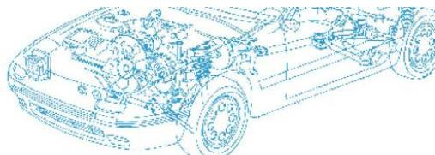 | 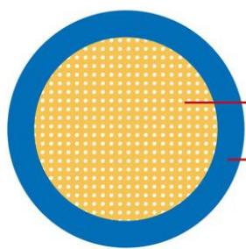
FLRY-B · Primary | FLRY-B · Gallery

PRODUCT OVERVIEW
NexPro FLRY-B Thin-Wall Automotive Wire is supplied as a configurable automotive cable product family. Catalog models are preserved exactly as FLRY-B. Use the source-derived tables below to select the required conductor construction, core arrangement, cross-section and dimensions.
Product line | Cable & Wire for Electrical, ELV and Industrial Projects
Series / family | Automotive cable
Exact model | FLRY-B
Applications | Equipment connections, Flexible wiring, OEM electrical assemblies
MODEL IDENTIFICATION
Exact model | Product / variant | Cable category | Catalog model | Configuration
FLRY-B | FLRY-B Thin-Wall Automotive Wire | Automotive cable | FLRY-B | Select from source table
TECHNICAL SPECIFICATIONS
Parameter | Specification
Cable category | Automotive cable
Catalog model | FLRY-B
Configuration | Select from source table
Manufacturer models | FLRY-B
Nominal Cross-section | Conductor: No. and Dia. of Wires | Insulation: Diameter max. | Cable: Resistance at 20°C Bare/Tinned max.
mm^2 | Conductor: No./mm | Insulation: mm | Cable: mΩ/m
1x0.35 | Conductor: 12/0.21 | Insulation: 0.90 | Cable: 52.00/5.50
1x0.50 | Conductor: 16/0.21 | Insulation: 1.00 | Cable: 37.10/38.20
1x0.75 | Conductor: 24/0.21 | Insulation: 1.20 | Cable: 24.70/25.40
1x1.00 | Conductor: 32/0.21 | Insulation: 1.35 | Cable: 18.50/19.10
1x1.50 | Conductor: 30/0.26 | Insulation: 1.70 | Cable: 12.70/13.00
1x2.00 | Conductor: 30/0.31 | Insulation: 1.90 | Cable: 9.31/9.59
ENGINEERING TABLES
FLRY-B · Source Specification Table 1
Column 1 | Conductor | Insulation | Cable
Nominal Cross-section | No. and Dia. of Wires | Diameter max. | Resistance at 20°C Bare/Tinned max.
mm^2 | No./mm | mm | mΩ/m
1x0.35 | 12/0.21 | 0.90 | 52.00/5.50
1x0.50 | 16/0.21 | 1.00 | 37.10/38.20
1x0.75 | 24/0.21 | 1.20 | 24.70/25.40
1x1.00 | 32/0.21 | 1.35 | 18.50/19.10
1x1.50 | 30/0.26 | 1.70 | 12.70/13.00
1x2.00 | 30/0.31 | 1.90 | 9.31/9.59
1x2.50 | 50/0.26 | 2.20 | 7.60/7.80
1x3.00 | 45/0.31 | 2.40 | 6.21/6.40
1x4.00 | 56/0.31 | 2.75 | 4.70/4.80
1x6.00 | 84/0.31 | 3.30 | 3.10/3.20
1x10.00 | 80/0.41 | 4.50 | 1.82/1.85
1x16.00 | 126/0.41 | 6.30 | 1.16/1.18
1x25.00 | 196/0.41 | 7.80 | 0.74/0.76

