
CABLE & WIRE FOR ELECTRICAL, ELV AND INDUSTRIAL PROJECTS

BS 6004 624-Y Twin and Earth PVC Cable
  - Models: 624-Y | NYM-J | NYM-O
PRODUCT IMAGES
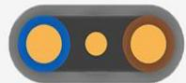 | 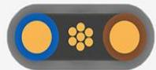 | 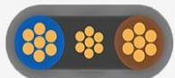 | 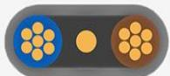
624-Y · Primary | 624-Y · Gallery | 624-Y · Gallery | 624-Y · Gallery

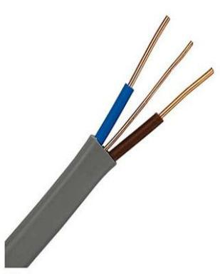 | 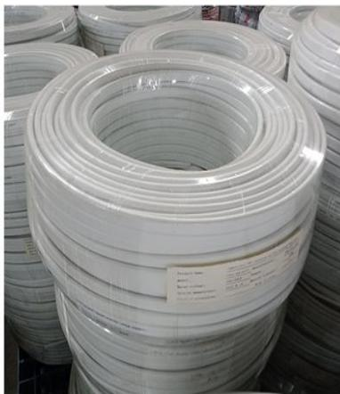 | 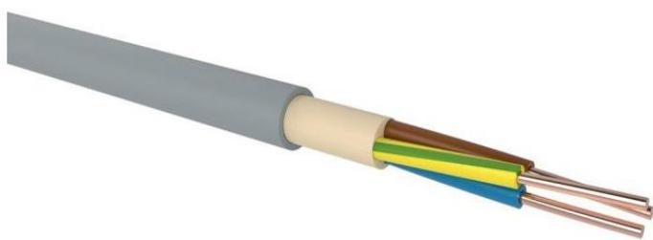
624-Y · Gallery | 624-Y · Gallery | NYM-J | NYM-O · Primary

PRODUCT OVERVIEW
NexPro BS 6004 624-Y Twin and Earth PVC Cable is supplied as a configurable fixed installation cable product family. Catalog models are preserved exactly as 624-Y. Use the source-derived tables below to select the required conductor construction, core arrangement, cross-section and dimensions.
Product line | Cable & Wire for Electrical, ELV and Industrial Projects
Series / family | Fixed installation cable
Exact model | 624-Y | NYM-J | NYM-O
Applications | Building wiring, Electrical panels, Fixed installation projects
MODEL COMPARISON
Exact model | Product / variant | Cable category | Catalog model | Configuration
624-Y | BS 6004 624-Y Twin and Earth PVC Cable | Fixed installation cable | 624-Y | Select from source table
NYM-J | NYM-O | NYM-J / NYM-O PVC Installation Cable | Fixed installation cable | NYM-J | NYM-O | Select from source table
TECHNICAL SPECIFICATIONS
Parameter | 624-Y | NYM-J | NYM-O
Cable category | Fixed installation cable | Fixed installation cable
Catalog model | 624-Y | NYM-J | NYM-O
Configuration | Select from source table | Select from source table
Manufacturer models | 624-Y | NYM-J / NYM-O
Specification status | No numeric source table was published for this product family | Not provided
Selection guidance | Confirm the exact model, voltage rating, conductor or core configuration, cross-section, installation conditions, required length and applicable project requirements in the RFQ. | Not provided
2 x 1.5 RE | Not provided | Specified value: 12.1 | Value 2: 0.42 | Value 3: 8.8 | Value 4: 115 | Value 5: 100 R, 500 Sp
3 x 1.5 RE | Not provided | Specified value: 12.1 | Value 2: 0.44 | Value 3: 8.5 | Value 4: 120 | Value 5: 100 R, 500 Sp
4 x 1.5 RE | Not provided | Specified value: 12.1 | Value 2: 0.53 | Value 3: 9.3 | Value 4: 145 | Value 5: 100 R, 500 Sp
5 x 1.5 RE | Not provided | Specified value: 12.1 | Value 2: 0.58 | Value 3: 10.2 | Value 4: 170 | Value 5: 100 R, 500 Sp
7 x 1.5 RE | Not provided | Specified value: 12.1 | Value 2: 0.67 | Value 3: 12.3 | Value 4: 235 | Value 5: 1000 D
10 x 1.5 RE | Not provided | Specified value: 12.1 | Value 2: 1.05 | Value 3: 14.3 | Value 4: 330 | Value 5: 500 Sp, 1000 Sp
12 x 1.5 RE | Not provided | Specified value: 12.1 | Value 2: 1.17 | Value 3: 14.4 | Value 4: 400 | Value 5: 100 R, 500 Sp
3 x 2.5 RE | Not provided | Specified value: 7.41 | Value 2: 0.58 | Value 3: 9.9 | Value 4: 165 | Value 5: 100 R, 500 Sp
ENGINEERING TABLES
NYM-J | NYM-O · NYM-J or -O
Parameter | Specified value | Value 2 | Value 3 | Value 4 | Value 5
2 x 1.5 RE | 12.1 | 0.42 | 8.8 | 115 | 100 R, 500 Sp
3 x 1.5 RE | 12.1 | 0.44 | 8.5 | 120 | 100 R, 500 Sp
4 x 1.5 RE | 12.1 | 0.53 | 9.3 | 145 | 100 R, 500 Sp
5 x 1.5 RE | 12.1 | 0.58 | 10.2 | 170 | 100 R, 500 Sp
7 x 1.5 RE | 12.1 | 0.67 | 12.3 | 235 | 1000 D
10 x 1.5 RE | 12.1 | 1.05 | 14.3 | 330 | 500 Sp, 1000 Sp
12 x 1.5 RE | 12.1 | 1.17 | 14.4 | 400 | 100 R, 500 Sp
3 x 2.5 RE | 7.41 | 0.58 | 9.9 | 165 | 100 R, 500 Sp
4 x 2.5 RE | 7.41 | 0.67 | 10.7 | 205 | 100 R, 500 Sp
5 x 2.5 RE | 7.41 | 0.72 | 11.7 | 245 | 100 R, 500 Sp
7 x 2.5 RE | 7.41 | 0.88 | 14.5 | 335 | 1000 D
3 x 4 RE | 4.61 | 0.72 | 10.8 | 265 | 1000 D
4 x 4 RE | 4.61 | 0.92 | 12.8 | 305 | 1000 D
5 x 4 RE | 4.61 | 1.11 | 13.9 | 370 | 1000 D
5 x 6 RE | 3.08 | 1.28 | 15.1 | 460 | 1000 D

