
CABLE & WIRE FOR ELECTRICAL, ELV AND INDUSTRIAL PROJECTS

BV PVC Insulated Solid Copper Wire
  - Models: 60227 IEC 01 (BV) | BVR
PRODUCT IMAGES
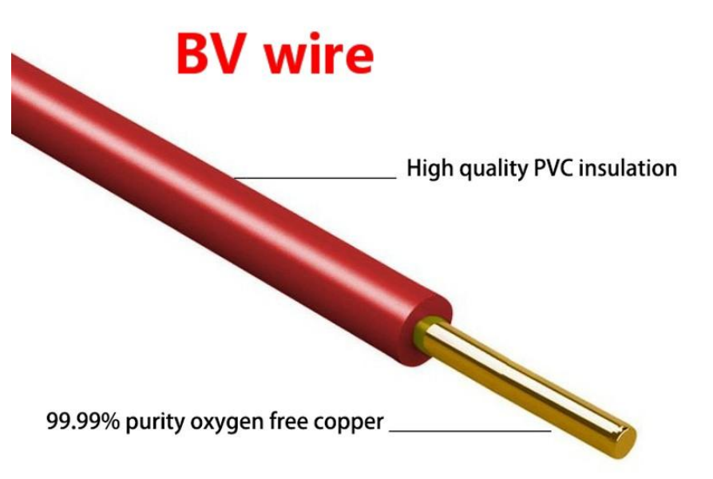 | 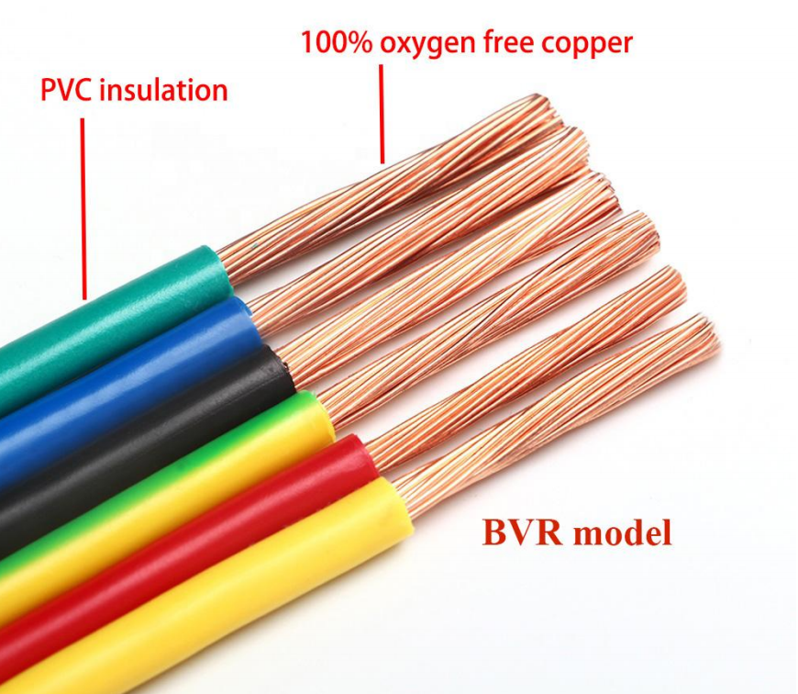
60227 IEC 01 (BV) · Primary | BVR · Primary

PRODUCT OVERVIEW
NexPro BV PVC Insulated Solid Copper Wire is supplied as a configurable house wire product family. Catalog models are preserved exactly as 60227 IEC 01 (BV). Use the source-derived tables below to select the required conductor construction, core arrangement, cross-section and dimensions.
Product line | Cable & Wire for Electrical, ELV and Industrial Projects
Series / family | House wire
Exact model | 60227 IEC 01 (BV) | BVR
Applications | Building wiring, Electrical panels, Fixed installation projects
MODEL COMPARISON
Exact model | Product / variant | Cable category | Catalog model | Configuration
60227 IEC 01 (BV) | BV PVC Insulated Solid Copper Wire | House wire | 60227 IEC 01 (BV) | Select from source table
BVR | BVR PVC Insulated Flexible Copper Wire | House wire | BVR | Select from source table
TECHNICAL SPECIFICATIONS
Parameter | 60227 IEC 01 (BV) | BVR
Cable category | House wire | House wire
Catalog model | 60227 IEC 01 (BV) | BVR
Configuration | Select from source table | Select from source table
Manufacturer models | 60227 IEC 01 (BV) | BVR
Specification status | No numeric source table was published for this product family | No numeric source table was published for this product family
Selection guidance | Confirm the exact model, voltage rating, conductor or core configuration, cross-section, installation conditions, required length and applicable project requirements in the RFQ. | Confirm the exact model, voltage rating, conductor or core configuration, cross-section, installation conditions, required length and applicable project requirements in the RFQ.
APPLICATIONS & RFQ CONFIRMATION
Typical applications | Confirm in the project RFQ
Building wiring  Electrical panels  Fixed installation projects  Equipment connections  Flexible wiring  OEM electrical assemblies | Confirm conductor material and construction, core count and cross-section.  Confirm voltage/model, installation method and environmental conditions.  Confirm required length, drum or coil packing, quantity and destination requirements.
Project supply: MOQ — Confirm by cable type, size and length · Lead time — Confirm after specification review · FOB port — Confirm in project quotation · OEM/ODM — To be confirmed
PROJECT CONFIGURATION CHECKLIST
Exact model | 60227 IEC 01 (BV)
Application and site conditions | Confirm installation environment and operating requirements.
Quantity and model mix | Confirm forecast quantity, phase plan and required variants.
Interfaces and accessories | Confirm compatible interfaces, accessories and system integration scope.
Finish, branding and packing | Confirm only when project customization is required.
Documentation and destination | Confirm drawings, datasheets, packing documents and destination country or port.

