
CABLE & WIRE FOR ELECTRICAL, ELV AND INDUSTRIAL PROJECTS

YJV22 Copper XLPE Insulated Steel Tape Armoured Cable
  - Exact model: YJV22
PRODUCT IMAGES
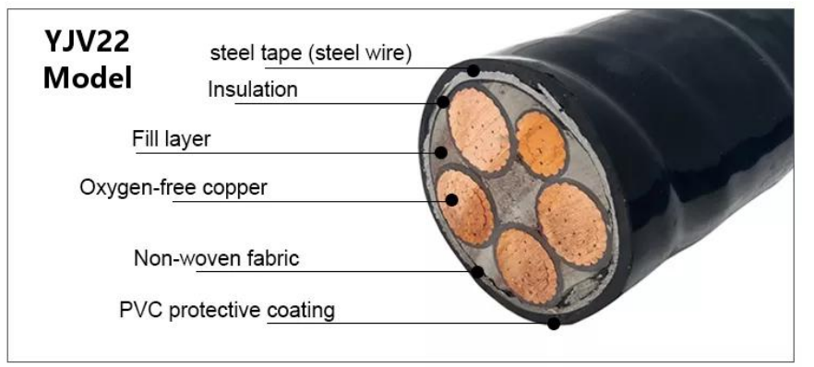 | 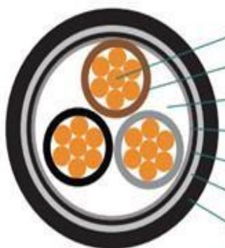 | 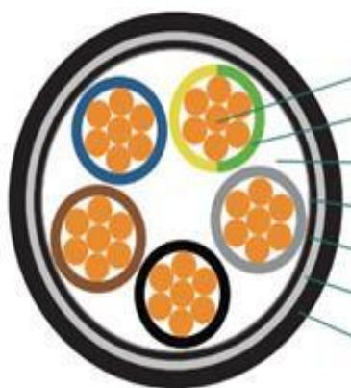 | 
YJV22 · Primary | YJV22 · Gallery | YJV22 · Gallery | YJV22 · Gallery

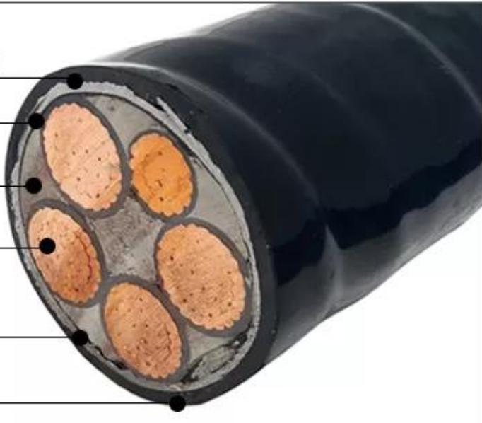 | 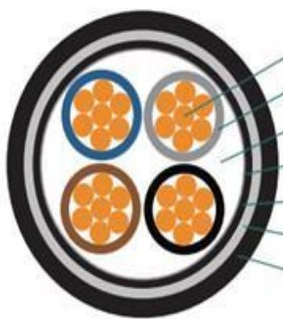
YJV22 · Gallery | YJV22 · Gallery

PRODUCT OVERVIEW
NexPro YJV22 Copper XLPE Insulated Steel Tape Armoured Cable is supplied as a configurable armoured xlpe power cable product family. Catalog models are preserved exactly as YJV22. Use the source-derived tables below to select the required conductor construction, core arrangement, cross-section and dimensions.
Product line | Cable & Wire for Electrical, ELV and Industrial Projects
Series / family | Armoured XLPE power cable
Exact model | YJV22
Applications | Low-voltage distribution, Industrial power projects, Fixed and buried installations
MODEL IDENTIFICATION
Exact model | Product / variant | Cable category | Catalog model | Configuration
YJV22 | YJV22 Copper XLPE Insulated Steel Tape Armoured Cable | Armoured XLPE power cable | YJV22 | Select from source table
TECHNICAL SPECIFICATIONS
Parameter | Specification
Cable category | Armoured XLPE power cable
Catalog model | YJV22
Configuration | Select from source table
Manufacturer models | YJV22
Specification status | No numeric source table was published for this product family
Selection guidance | Confirm the exact model, voltage rating, conductor or core configuration, cross-section, installation conditions, required length and applicable project requirements in the RFQ.
APPLICATIONS & RFQ CONFIRMATION
Typical applications | Confirm in the project RFQ
Low-voltage distribution  Industrial power projects  Fixed and buried installations | Confirm conductor material and construction, core count and cross-section.  Confirm voltage/model, installation method and environmental conditions.  Confirm required length, drum or coil packing, quantity and destination requirements.
Project supply: MOQ — Confirm by cable type, size and length · Lead time — Confirm after specification review · FOB port — Confirm in project quotation · OEM/ODM — To be confirmed
PROJECT CONFIGURATION CHECKLIST
Exact model | YJV22
Application and site conditions | Confirm installation environment and operating requirements.
Quantity and model mix | Confirm forecast quantity, phase plan and required variants.
Interfaces and accessories | Confirm compatible interfaces, accessories and system integration scope.
Finish, branding and packing | Confirm only when project customization is required.
Documentation and destination | Confirm drawings, datasheets, packing documents and destination country or port.

