
CABLE & WIRE FOR ELECTRICAL, ELV AND INDUSTRIAL PROJECTS

YJLV Aluminum XLPE Insulated PVC Sheathed Cable
  - Exact model: YJLV
PRODUCT IMAGES
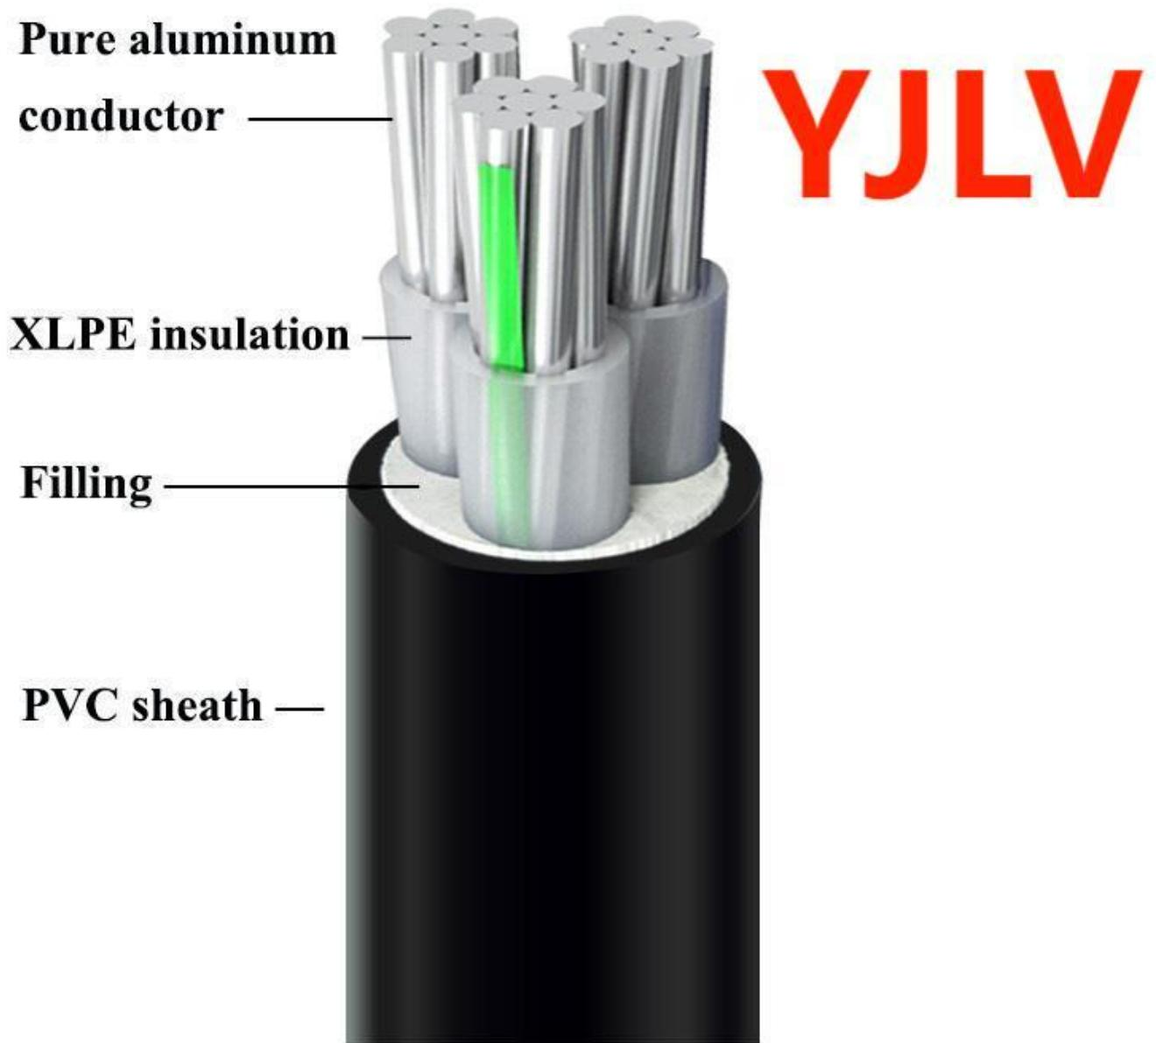
YJLV · Primary

PRODUCT OVERVIEW
NexPro YJLV Aluminum XLPE Insulated PVC Sheathed Cable is supplied as a configurable aluminum xlpe power cable product family. Catalog models are preserved exactly as YJLV. Use the source-derived tables below to select the required conductor construction, core arrangement, cross-section and dimensions.
Product line | Cable & Wire for Electrical, ELV and Industrial Projects
Series / family | Aluminum XLPE power cable
Exact model | YJLV
Applications | Low-voltage distribution, Industrial power projects, Fixed and buried installations
MODEL IDENTIFICATION
Exact model | Product / variant | Cable category | Catalog model | Configuration
YJLV | YJLV Aluminum XLPE Insulated PVC Sheathed Cable | Aluminum XLPE power cable | YJLV | Select from source table
TECHNICAL SPECIFICATIONS
Parameter | Specification
Cable category | Aluminum XLPE power cable
Catalog model | YJLV
Configuration | Select from source table
Manufacturer models | YJLV
Specification status | No numeric source table was published for this product family
Selection guidance | Confirm the exact model, voltage rating, conductor or core configuration, cross-section, installation conditions, required length and applicable project requirements in the RFQ.
APPLICATIONS & RFQ CONFIRMATION
Typical applications | Confirm in the project RFQ
Low-voltage distribution  Industrial power projects  Fixed and buried installations | Confirm conductor material and construction, core count and cross-section.  Confirm voltage/model, installation method and environmental conditions.  Confirm required length, drum or coil packing, quantity and destination requirements.
Project supply: MOQ — Confirm by cable type, size and length · Lead time — Confirm after specification review · FOB port — Confirm in project quotation · OEM/ODM — To be confirmed
PROJECT CONFIGURATION CHECKLIST
Exact model | YJLV
Application and site conditions | Confirm installation environment and operating requirements.
Quantity and model mix | Confirm forecast quantity, phase plan and required variants.
Interfaces and accessories | Confirm compatible interfaces, accessories and system integration scope.
Finish, branding and packing | Confirm only when project customization is required.
Documentation and destination | Confirm drawings, datasheets, packing documents and destination country or port.

