
CABLE & WIRE FOR ELECTRICAL, ELV AND INDUSTRIAL PROJECTS

Photovoltaic Solar Cable
  - Exact model: PV Solar Cable
PRODUCT IMAGES
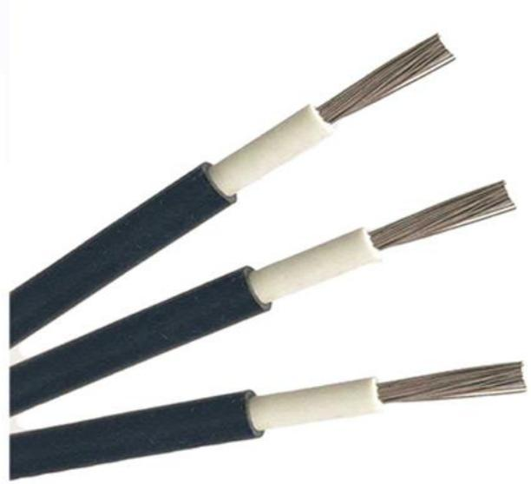 | 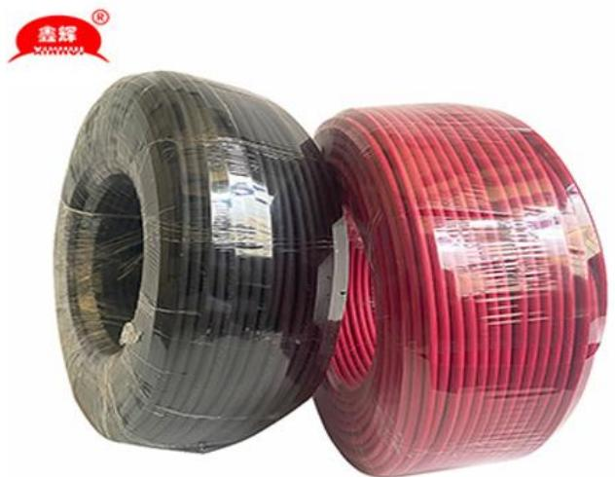 | 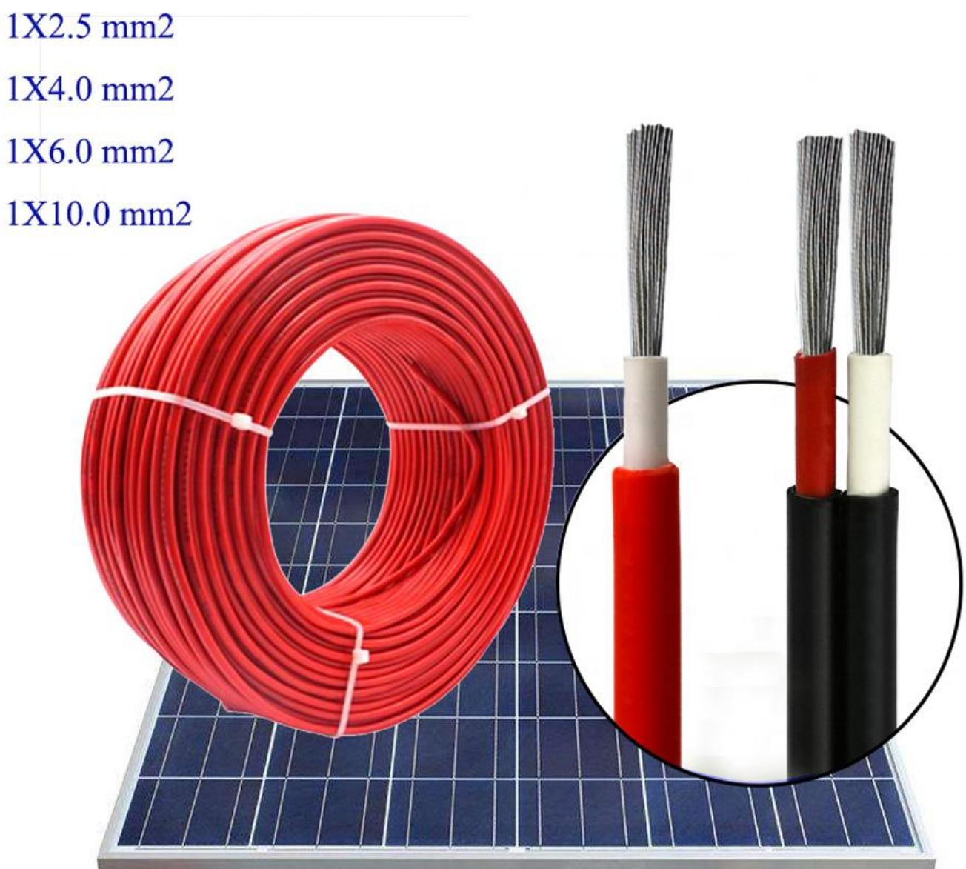
PV Solar Cable · Primary | PV Solar Cable · Gallery | PV Solar Cable · Gallery

PRODUCT OVERVIEW
NexPro Photovoltaic Solar Cable is supplied as a configurable photovoltaic cable product family. Catalog models are preserved exactly as PV Solar Cable. Use the source-derived tables below to select the required conductor construction, core arrangement, cross-section and dimensions.
Product line | Cable & Wire for Electrical, ELV and Industrial Projects
Series / family | Photovoltaic cable
Exact model | PV Solar Cable
Applications | Solar and utility projects, Outdoor distribution, Project-specific installations
MODEL IDENTIFICATION
Exact model | Product / variant | Cable category | Catalog model | Configuration
PV Solar Cable | Photovoltaic Solar Cable | Photovoltaic cable | PV Solar Cable | Select from source table
TECHNICAL SPECIFICATIONS
Parameter | Specification
Cable category | Photovoltaic cable
Catalog model | PV Solar Cable
Configuration | Select from source table
Manufacturer models | PV Solar Cable
1.5 | Monofilament diameter mm / number of pieces: 0.25/30 | conductor outer diameter mm: 1.6 | Insulation thickness mm: 0.5 | Sheath thickness mm: 0.5 | Finished outer diameter mm: 3.6-4.0 | Approximate weight /km/kg: 32.33
2.5 | Monofilament diameter mm / number of pieces: 0.25/49 | conductor outer diameter mm: 2.1 | Insulation thickness mm: 0.5 | Sheath thickness mm: 0.5 | Finished outer diameter mm: 4.1-4.4 | Approximate weight /km/kg: 36.82
4 | Monofilament diameter mm / number of pieces: 0.30/56 | conductor outer diameter mm: 2.6 | Insulation thickness mm: 0.7 | Sheath thickness mm: 0.7 | Finished outer diameter mm: 5.4-5.7 | Approximate weight /km/kg: 67.89
6 | Monofilament diameter mm / number of pieces: 0.30/84 | conductor outer diameter mm: 3.2 | Insulation thickness mm: 0.7 | Sheath thickness mm: 0.7 | Finished outer diameter mm: 6.5-6.9 | Approximate weight /km/kg: 75.44
10 | Monofilament diameter mm / number of pieces: 0.40/80 | conductor outer diameter mm: 4.1 | Insulation thickness mm: 0.8 | Sheath thickness mm: 0.7 | Finished outer diameter mm: 7.1-7.5 | Approximate weight /km/kg: 95.64
16 | Monofilament diameter mm / number of pieces: 0.40/126 | conductor outer diameter mm: 5.2 | Insulation thickness mm: 0.8 | Sheath thickness mm: 0.7 | Finished outer diameter mm: 8.2-8.7 | Approximate weight /km/kg: 110.46
25 | Monofilament diameter mm / number of pieces: 0.40/196 | conductor outer diameter mm: 6.5 | Insulation thickness mm: 1 | Sheath thickness mm: 0.9 | Finished outer diameter mm: 10.3-10.7 | Approximate weight /km/kg: 175.75
35 | Monofilament diameter mm / number of pieces: 0.40/276 | conductor outer diameter mm: 7.7 | Insulation thickness mm: 1 | Sheath thickness mm: 0.9 | Finished outer diameter mm: 11.5-12.5 | Approximate weight /km/kg: 196.22
ENGINEERING TABLES
PV Solar Cable · Source Specification Table 1
Cross-sectional area mm² | Monofilament diameter mm / number of pieces | conductor outer diameter mm | Insulation thickness mm | Sheath thickness mm | Finished outer diameter mm | Approximate weight /km/kg
1.5 | 0.25/30 | 1.6 | 0.5 | 0.5 | 3.6-4.0 | 32.33
2.5 | 0.25/49 | 2.1 | 0.5 | 0.5 | 4.1-4.4 | 36.82
4 | 0.30/56 | 2.6 | 0.7 | 0.7 | 5.4-5.7 | 67.89
6 | 0.30/84 | 3.2 | 0.7 | 0.7 | 6.5-6.9 | 75.44
10 | 0.40/80 | 4.1 | 0.8 | 0.7 | 7.1-7.5 | 95.64
16 | 0.40/126 | 5.2 | 0.8 | 0.7 | 8.2-8.7 | 110.46
25 | 0.40/196 | 6.5 | 1 | 0.9 | 10.3-10.7 | 175.75
35 | 0.40/276 | 7.7 | 1 | 0.9 | 11.5-12.5 | 196.22

