
CABLE & WIRE FOR ELECTRICAL, ELV AND INDUSTRIAL PROJECTS

NYY 0.6/1 kV PVC Power Cable
  - Exact model: NYY
PRODUCT IMAGES
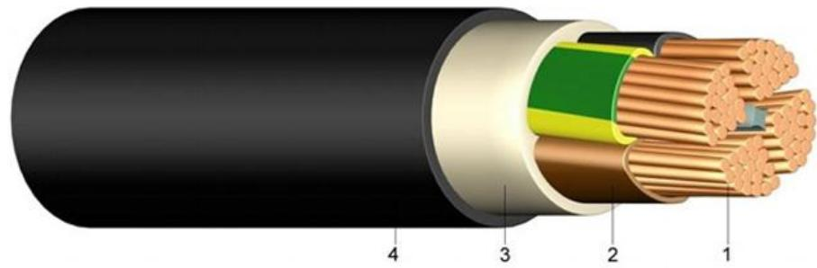 | 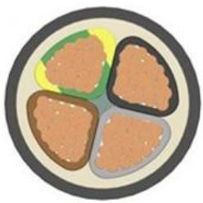
NYY · Primary | NYY · Gallery

PRODUCT OVERVIEW
NexPro NYY 0.6/1 kV PVC Power Cable is supplied as a configurable low-voltage power cable product family. Catalog models are preserved exactly as NYY. Use the source-derived tables below to select the required conductor construction, core arrangement, cross-section and dimensions.
Product line | Cable & Wire for Electrical, ELV and Industrial Projects
Series / family | Low-voltage power cable
Exact model | NYY
Applications | Low-voltage distribution, Industrial power projects, Fixed and buried installations
MODEL IDENTIFICATION
Exact model | Product / variant | Cable category | Catalog model | Configuration
NYY | NYY 0.6/1 kV PVC Power Cable | Low-voltage power cable | NYY | Select from source table
TECHNICAL SPECIFICATIONS
Parameter | Specification
Cable category | Low-voltage power cable
Catalog model | NYY
Configuration | Select from source table
Manufacturer models | NYY
Nominal voltage Uo/U | Specified value: | Value 2: [V] | Value 3: 600 / 1000 Volt
Test voltage | Specified value: | Value 2: [V]_{AC} | Value 3: 4000
Temperature range | Specified value: in motion | Value 2: | Value 3: - 5°C till +70°C
fixed | Specified value: | Value 2: -20°C till +70°C | Value 3: —
Bending radius | Specified value: single-core style | Value 2: x diameter | Value 3: 15
multi-core style | Specified value: x diameter | Value 2: 12 | Value 3: —
Flammability | Specified value: standard | Value 2: | Value 3: EN 60332-1-2
ENGINEERING TABLES
NYY · Technical data:
Parameter | Specified value | Value 2 | Value 3
Nominal voltage Uo/U | Not provided | [V] | 600 / 1000 Volt
Test voltage | Not provided | [V]_{AC} | 4000
Temperature range | in motion | Not provided | - 5°C till +70°C
fixed | Not provided | -20°C till +70°C | —
Bending radius | single-core style | x diameter | 15
multi-core style | x diameter | 12 | —
Flammability | standard | Not provided | EN 60332-1-2
NYY · Source Specification Table 2
Number of cores and nominal cross section | Copper figure | Overall diameter | Weight | Current carrying capacity ground | Current carrying capacity air
mm^2 | kg/km | appr. mm | kg/km | A | A
1 x 4 RE | 38,4 | 8 | 120 | 50 | 37
1 x 6 RE | 57,6 | 9 | 131 | 62 | 47
1 x 10 RE | 96,0 | 10 | 171 | 83 | 64
1 x 16 RE | 153,6 | 11 | 233 | 107 | 84
1 x 25 RM | 240,0 | 12 | 370 | 138 | 114
1 x 35 RM | 336,0 | 14 | 480 | 164 | 139
1 x 50 RM | 480,0 | 16 | 640 | 195 | 169
1 x 70 RM | 672,0 | 17 | 850 | 238 | 213
1 x 95 RM | 912,0 | 19 | 1.120 | 286 | 264
1 x 120 RM | 1.152,0 | 21 | 1.375 | 325 | 307
1 x 150 RM | 1.440,0 | 23 | 1.660 | 365 | 352
1 x 185 RM | 1.776,0 | 25 | 2.050 | 413 | 406
1 x 240 RM | 2.304,0 | 28 | 2.634 | 479 | 483
1 x 300 RM | 2.880,0 | 30 | 3.295 | 541 | 557

