
CABLE & WIRE FOR ELECTRICAL, ELV AND INDUSTRIAL PROJECTS

N2XY 0.6/1 kV XLPE/PVC Power Cable
  - Exact model: N2XY-J | N2XY-O | N2XY-JZ | N2XY-OZ
PRODUCT IMAGES
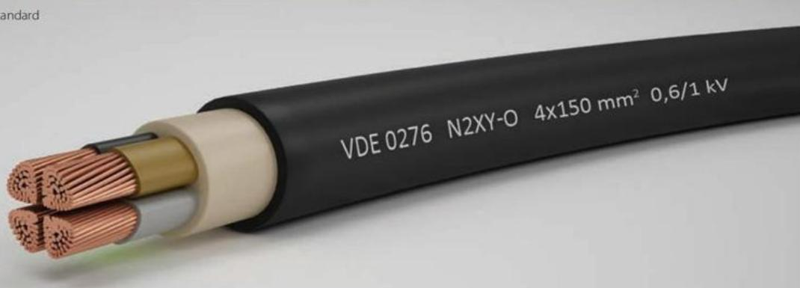
N2XY-J | N2XY-O | N2XY-JZ | N2XY-OZ · Primary

PRODUCT OVERVIEW
NexPro N2XY 0.6/1 kV XLPE/PVC Power Cable is supplied as a configurable low-voltage power cable product family. Catalog models are preserved exactly as N2XY-J, N2XY-O, N2XY-JZ, N2XY-OZ. Use the source-derived tables below to select the required conductor construction, core arrangement, cross-section and dimensions.
Product line | Cable & Wire for Electrical, ELV and Industrial Projects
Series / family | Low-voltage power cable
Exact model | N2XY-J | N2XY-O | N2XY-JZ | N2XY-OZ
Applications | Low-voltage distribution, Industrial power projects, Fixed and buried installations
MODEL IDENTIFICATION
Exact model | Product / variant | Cable category | Catalog model | Configuration
N2XY-J | N2XY-O | N2XY-JZ | N2XY-OZ | N2XY 0.6/1 kV XLPE/PVC Power Cable | Low-voltage power cable | N2XY-J | N2XY-O | N2XY-JZ | N2XY-OZ | Select from source table
TECHNICAL SPECIFICATIONS
Parameter | Specification
Cable category | Low-voltage power cable
Catalog model | N2XY-J | N2XY-O | N2XY-JZ | N2XY-OZ
Configuration | Select from source table
Manufacturer models | N2XY-J / N2XY-O / N2XY-JZ / N2XY-OZ
Source parameter | With protective conductor: N2XY-J | Without protective conductor: N2XY-O; With protective conductor: N2XY-JZ | Without protective conductor: N2XY-OZ
1 | With protective conductor: gn/ye | Without protective conductor: bk
2 | With protective conductor: - | Without protective conductor: bu, bn
3 | With protective conductor: gn/ye, bu, bn | Without protective conductor: bn, bk, gy
4 | With protective conductor: gn/ye, bn, bk, gy | Without protective conductor: bu, bn, bk, gy
5 | With protective conductor: gn/ye, bu, bn, bk, gy | Without protective conductor: bu, bn, bk, gy, bk
>5 | With protective conductor: gn/ye, black cores with white numbering | Without protective conductor: black cores with white numbering
ENGINEERING TABLES
N2XY-J | N2XY-O | N2XY-JZ | N2XY-OZ · Source Specification Table 1
Number of cores | With protective conductor | Without protective conductor
Not provided | N2XY-J | N2XY-O
1 | gn/ye | bk
2 | - | bu, bn
3 | gn/ye, bu, bn | bn, bk, gy
4 | gn/ye, bn, bk, gy | bu, bn, bk, gy
5 | gn/ye, bu, bn, bk, gy | bu, bn, bk, gy, bk
Not provided | N2XY-JZ | N2XY-OZ
>5 | gn/ye, black cores with white numbering | black cores with white numbering

