
CABLE & WIRE FOR ELECTRICAL, ELV AND INDUSTRIAL PROJECTS

H05V-K Flexible PVC Insulated Wire
  - Exact model: H05V-K
PRODUCT IMAGES
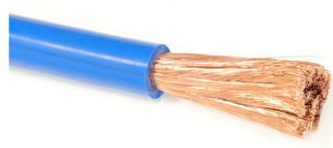 | 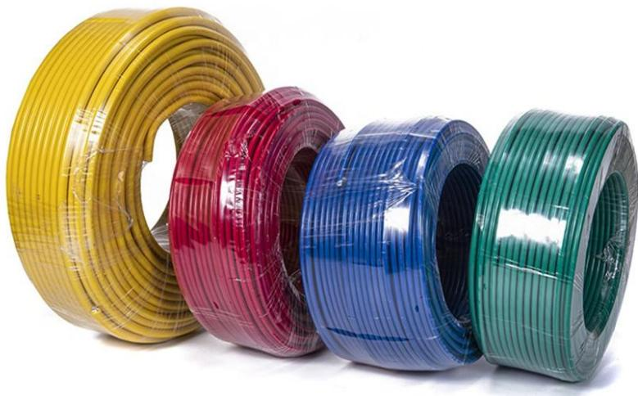
H05V-K · Primary | H05V-K · Gallery

PRODUCT OVERVIEW
NexPro H05V-K Flexible PVC Insulated Wire is supplied as a configurable single-core flexible wire product family. Catalog models are preserved exactly as H05V-K. Use the source-derived tables below to select the required conductor construction, core arrangement, cross-section and dimensions.
Product line | Cable & Wire for Electrical, ELV and Industrial Projects
Series / family | Single-core flexible wire
Exact model | H05V-K
Applications | Equipment connections, Flexible wiring, OEM electrical assemblies
MODEL IDENTIFICATION
Exact model | Product / variant | Cable category | Catalog model | Configuration
H05V-K | H05V-K Flexible PVC Insulated Wire | Single-core flexible wire | H05V-K | Select from source table
TECHNICAL SPECIFICATIONS
Parameter | Specification
Cable category | Single-core flexible wire
Catalog model | H05V-K
Configuration | Select from source table
Manufacturer models | H05V-K
1x0,5 | Resistance at 20 °C  (Ohm/km): 39 | External Diameter (mm): 2,15 | Weight (kg/km): 9 | Class: Eca
1x0,75 | Resistance at 20 °C  (Ohm/km): 26 | External Diameter (mm): 2,25 | Weight (kg/km): 11 | Class: Eca
1x1 | Resistance at 20 °C  (Ohm/km): 19,5 | External Diameter (mm): 2,50 | Weight (kg/km): 14 | Class: Eca
ENGINEERING TABLES
H05V-K · Source Specification Table 1
Section (mm²) | Resistance at 20 °C (Ohm/km) | External Diameter (mm) | Weight (kg/km) | Class
1x0,5 | 39 | 2,15 | 9 | Eca
1x0,75 | 26 | 2,25 | 11 | Eca
1x1 | 19,5 | 2,50 | 14 | Eca
H05V-K · Source Specification Table 2
1. Conductor | Flexible electrolytic copper conductor (Class V) according to BS EN 60228:2005 (previously BS6360) and EN 60228.
2. Insulation | PVC insulation type TI-1 according to BS7655 and HD 21.3S3:1995/A2:2008.
Nominal voltage | 300/500 V
Test voltage | 2.000 V A.C.
Maximum temperature | 70 °C
Other characteristics | —
Colours according to HD 21.1S4:2002Non-flame propagating according to UNE-EN 60332-1-2, EN 60332-1-2 and IEC 60332-1-2CPR Classification according to EN 50575 | —

